Ari-Ana: The Intussusception Reduction Simulator

Copyright 2013 by Lucy, LLC

All rights reserved.Overview of Intussusception

Presentation: Intussusception is the most common cause of acute intestinal obstruction in young children. It usually occurs in children between three months and two years of age, and it is more common in boys[1]. The classic triad of signs and symptoms is abdominal pain, bloody or “currant jelly” stool, and a palpable abdominal mass, although it is uncommon for a patient to present with all three. Patients may present only with diarrhea, listlessness, obtundation, or shock.

Etiology: In an intussusception, a segment of bowel telescopes or prolapses into the adjacent downstream segment. There may be a lead point—a mass that peristaltic waves carry into the bowel—but as many as 95% of cases are considered idiopathic, caused by enlarged Peyers patches in the distal ileum. Pathologic lead points—most often focal processes such as inverted Meckel diverticulum, polyp, duplication cyst, lymphoma, and periappendicitis—are more common in patients older than 2 years. Diffuse pathologic lead points include Henoch-Schonlein purpura and cystic fibrosis[2].

Diagnosis and Treatment: Many centers employ ultrasound for diagnosis, and its accuracy approaches 100%[3]. Ultrasound can identify a pathologic lead point, and—in patients without intussusception—may determine the etiology for the patient’s symptoms, such as ovarian torsion or appendicitis. Ultrasound images with the transducer perpendicular to the loop of intussuscepted bowel demonstrate a “doughnut” formed by concentric circles of hypoechoic edematous bowel alternating with echogenic mesenteric fat. When the transducer is oriented along the axis of the bowel, the intussusception resembles a “pseudokidney.” Some centers prefer to use enema to both diagnose and treat intussusception, arguing that ultrasound is operator dependant and therefore unreliable, and that the time spent performing the ultrasound delays reduction—time that can be critical to prevent bowel necrosis.

Predicting Successful Reduction: The physician performing an enema will successfully reduce the intussusception between 80% and 98% of the time[1]. Success is less likely if the patient presents after more than 24 hours of symptoms, if the patient is dehydrated, if there is a complete small bowel obstruction[4], and in patients less than 6 months old. Rectal bleeding, ilioiliocolic intussusception, and a previous unsuccessful attempt at reduction at another institution may also predict failure[5]. Ultrasound findings of free peritoneal fluid, fluid trapped between intussuscepted layers of bowel[6, 7], and absence of blood flow at Doppler interrogation[8] are also associated with decreased success. However, reduction may succeed despite the presence of any of these factors[4], and since a successful reduction will spare the patient from surgery many radiologists will attempt a reduction despite these negative indicators.

Contraindications: Absolute contraindications for therapeutic enema are evidence of perforation (peritonitis or free air); dehydration/shock is a strong contraindication[9]. However, many pediatric radiologists attempt to reduce intussusceptions after successful hemodynamic stabilization of patients who present in shock.

Air vs Liquid: Either air or liquid enema can reduce intussusception, and either fluoroscopy or ultrasound can monitor reduction. In the United States, the use of ultrasound to monitor reduction is limited, but this technique is widespread in other parts of the world. Many centers in the U.S. have switched from predominant use of fluid to predominant use of air (unpublished data). There is ample evidence that air reduction has a higher probability of success, lower radiation dose, reduced peritoneal spillage of bowel contents in the event of perforation[5, 10-13], and results in an easier surgery and post-operative course[10]. However, perforation during an air reduction may cause potentially lethal tension pneumoperitoneum[14], and air enema is less likely than liquid contrast to define a pathological lead point. Air reduction technique is also reportedly more difficult to learn[15], which we hope to improve with this device[16]. Perforation occurs in about 1% of patients who undergo reduction with either technique[10].

Air Reduction Technique: The operator places a rectal tube and secures it in place with an airtight seal. This step is crucial, because the key to successful reduction is maintaining high pressure within the colon[17]. Some favor use of an occlusive balloon within the rectum, claiming that the balloon creates a better seal and increases the probability of success, but others prefer a straight catheter, citing an increased risk of perforation when using an occlusion balloon[1, 17]. Taping techniques vary and are best learned from an experienced pediatric radiologist (see list of suggested references). For example, in our practice we wrap 0.5 inch cloth adhesive tape around a straight catheter just beyond the anus, then advance the tube and push the ring of tape against the anal verge before securing the tube in place[17].

The maximum pressure that a radiologist should maintain within the patient’s colon during an attempted reduction is 120 mm Hg. However, when the patient performs the Valsalva maneuver (generally while crying) the pressure may briefly exceed this limit[18]. Many have adopted the liquid-reduction based guidelines of abandoning the procedure if the intussusceptum does not move after three attempts of three minutes each, but many pediatric radiologists are more aggressive in terms of duration and number of attempts, again because a successful reduction will spare the patient from a potentially avoidable surgery.

Some have described additional techniques that we were not able to include in this simulation. We suggest that the instructor discuss these:

1. Transabdominal manually assisted reduction[19]. “Milking, pressing, and/or jiggling action” can be employed. This resulted in successful reduction of 70% of cases after initial reduction had failed. However, there may be increased risk of perforation with manual reductionz[20].
2. Repeated, delayed air enema. Gorenstein[21] found that waiting 45 to 60 minutes after a failed reduction attempt and then repeating air reduction increased the radiologist’s likelihood of success from 70% to 91%. In clinically stable, asymptomatic infants, Connolly has waited several hours between successive attempts at reduction, with an overall time between presentation and eventual reduction of up to 24 hours[22].

Sedation: Practices vary. There is evidence that the Valsalva maneuver, which occurs when a child cries, provides some protection against perforation[12, 17, 18]. There is also evidence that exposing young children to anesthetics causes damage to developing neurons[23], and many therefore consider it desirable to avoid sedating a child if possible.

Complications: Perforation occurs in normal bowel at high pressures[10-12], or in necrotic bowel at normal or even low pressure[11, 18]. It is more common in infants less than 6 months old and in those with a longer duration of symptoms[5, 10].

If tension pneumoperitoneum occurs, as manifested by hypotension, hypoventilation, and a distended, tympanitic abdomen, the operator should immediately insert a large-bore IV catheter into the peritoneal cavity just above or below the umbilicus, angling the catheter to the horizontal[14]. The appropriate device must be available at the bedside before attempting reduction[10].

Recurrence: Intussusception recurs in 3.5% to 11% of patients[1, 24]. Re-reduction succeeds in as many as 95%, and risk of perforation does not necessarily increase[1, 24]. In the event of recurrence, it is especially important to search for a pathologic lead point.

## Getting started

When your simulator arrives: The simulator comes with a laptop, a doll with three tubes coming out of the back, and a manometer. See the following figures for the appropriate setup. Keep in mind that the doll, manometer, and laptop may differ slightly from the equipment shown here depending on availability.

First, remove the laptop from the box and turn it on. You may wish to plug it into a wall socket with the included charger. Turn on the laptop; the computer is preloaded will all the necessary software. Plug the included USB cable into the port on the left side of the manometer, power on the manometer, and plug the cable into one of the USB ports on the left side of the computer.

On the desktop, there is an icon labeled “ARIana.” Double-clicking that icon will start the program. At this point, you should be ready to go!

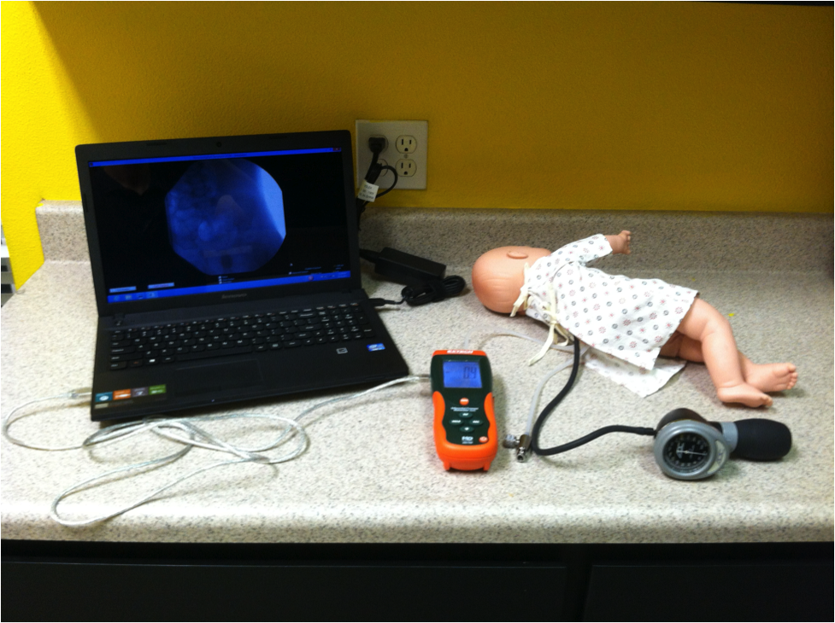

Note that there are three tubes protruding from the doll – one connected to the insufflater, one connected to the instructor’s control valve, and the third, which has to be connected to the manometer. Note that it should be connected to the right-hand port on the top of the manometer; if it is connected to the other port, the pressure will read negative and the program will terminate.

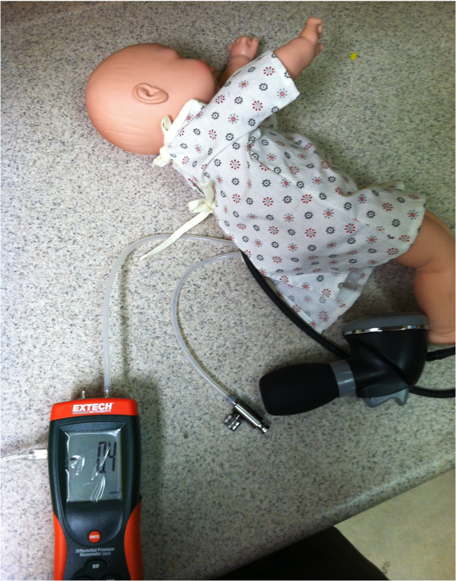

## Using the Simulator

Starting the Simulator – Disclaimer: When you double-click the desktop icon for the simulator, the first window that appears is the licensing agreement. This agreement ensures that you are using the simulator for its proper purpose – as a tool to teach radiologists how to reduce an intussusception using an air enema, to compliment rather than substitute for experience with real patients. The Instructor has the primary responsibility for teaching the Student how this is to be done; a student should not consider himself competent to independently perform this procedure solely on the basis of using this simulator.

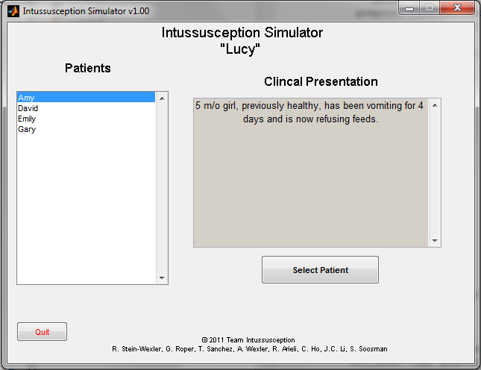

Figure : The Main Menu Window

Starting the Simulator – The Main Menu: The Main Menu is the first window that appears when the program starts. The window includes a list of patients. The student can single-click a patient’s name to bring up that patient’s clinical presentation in the field to the right of the list (there may be a slight delay). Once the student decides on a patient to examine, he or she clicks the “Select Patient” button. The Main Menu Window will close, and a Preprocedure Window will open with that patient’s clinical data and clinical images. (See the next section of this manual).

To quit the program at any time, click the red “Quit” button in the bottom left corner of the window and the program will close.

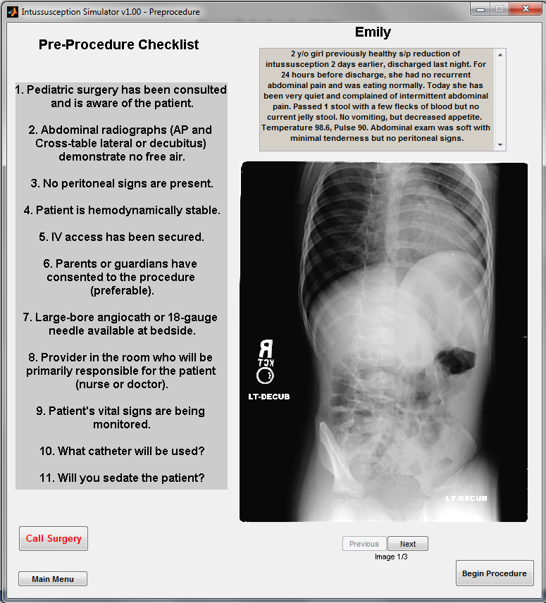

Figure : The Pre-Procedure Window

Preparing for the Reduction – The Pre-Procedure Window: After the student selects a patient, the preprocedure window (Figure 2) opens, containing some clinical images of the patient along with his or her clinical presentation. On the right side of the window, scout radiographs and other clinical images will be available for viewing. If there is more than one clinical image, the “Previous” and “Next” buttons will be visible, as well as a counter indicating how many clinical images are in the series.

The student and instructor can use this Window as an opportunity to discuss the plans for managing this patient, using the preprocedure checklist on the left side of the image as a guide. See the previous section of the manual for references that can be used to expand on any of the points in this checklist. If a scout image demonstrates any contraindications for an air reduction (i.e., free peritoneal air), surgery needs to be notified. In this case, the student clicks the red button labeled “Call Surgery.” A dialog box will appear, informing the student that the patient is being prepped for surgery. After the student clicks “OK” in the dialog box, the Pre-Procedure Window closes and the Main Menu Window opens. The student may also return to the Main Menu at any time by clicking on the “Main Menu” button.

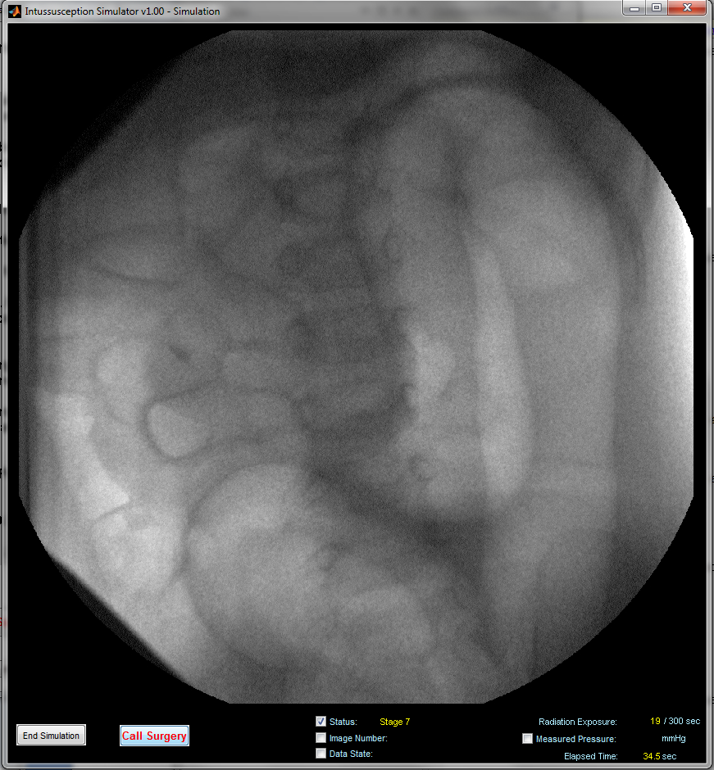

Figure : The Simulation Window

Reducing the Intussusception – The Simulation Window: Once the student begins a reduction, the Simulation Window appears (Figure 3). If you wish to reposition the window, wait for the initial image to display and then drag the window to the appropriate location. The simulated fluoroscope will display images of actual patient reductions that correspond to the stage of the simulated reduction. The student will pump air into the patient using the attached hand pump, being careful to monitor the pressure in the system with the attached pressure gauge. The student will press the space bar at intervals to check the progress of the reduction, simulating the way they would intermittently activate the fluoroscope when performing an air reduction. The student should frequently be evaluating the images in real time to determine how the reduction is progressing and whether there is evidence of complication (such as free air). The instructor should be evaluating the student’s progress and the ability of the student to recognize where the mass of intussuscepted bowel is located. Generally, reductions tend to progress quickly during the early stages, and more slowly as the simulation nears complete reduction.

Each time the student presses the space bar, the computer adds a small amount to the cumulative fluoroscopy time, quantified in the lower right corner under “Radiation Exposure.” If the count exceeds 300 seconds, the procedure will terminate, thus helping to reinforce the principle of using as little radiation as possible while maintaining a safe and effective reduction. The elapsed time for the procedure is displayed in the bottom right corner of the screen. Other values, such as “Image Number”, ”Data State” and “Measured Pressure” are all switched off by default, but can be enabled at any time by clicking the checkboxes next to the words**.**  The displayed values are for troubleshooting and for the instructor’s convenience. The “Status:” and “Image Number:” values show which stage of the reduction the student has reached and which image is being displayed, respectively.

“Data State:” helps the instructor know how the simulation is progressing. Most of the time, the word “stuck” will appear. That means that the position of the simulated intussuception is not changing. When the word “Success” appears (briefly), the simulation has moved to the next stage. When the word “Retrogress” appears, the simulated intussusception is retrogressing. When the word “perforated” appears, the simulated intussusception has resulted in a perforation.

It is important to note that the image displayed on the screen does not necessarily correspond to the current stage of the simulation; it is similar to the image hold function of a fluoroscope in that it displays the image corresponding to the stage of the simulation the last time the space bar was pressed. The image corresponding to the current stage will be displayed only after the student presses the space bar.

If a successful reduction occurs, as demonstrated by air refluxing into the terminal ileum and complete reduction of the intussusception, the student can end the simulation by clicking the “End Simulation” button located in the bottom-left corner of the screen.

If the student recognizes that the procedure has failed (e.g., if they notice free air in the abdomen), they can end the simulation by clicking the red “Call Surgery” button located next to the “End Simulation” button.

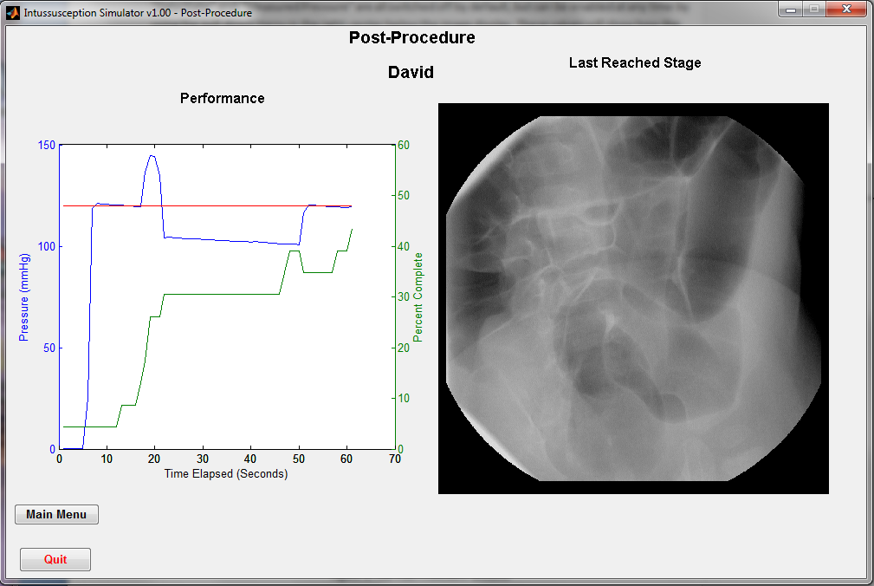

Figure : The Post Procedure Window

Post Procedure – Evaluating The Student: At the end of the simulation, the Simulation Window closes and the Post-Procedure Window opens (Figure 4). The graph on the left side of the window is a record of the pressure maintained in the simulator throughout the procedure and the rate at which the student reduced the simulated intussusception. The blue line represents the recorded pressure throughout the simulation. The red line indicates the optimal maximum pressure of 120 mmHg and is included for reference and comparison. The Green line demonstrates the rate at which the student was able to reduce the intussuception by advancing from stage 1 (the first stage) through the last. The image on the right of the performance graph is the fluoroscopic image corresponding to the last stage reached before the student ended the procedure.

If post-procedure images are available and the reduction is successful, additional buttons will appear below the last reached image allowing the student to view the post-procedure images (Figure 5).

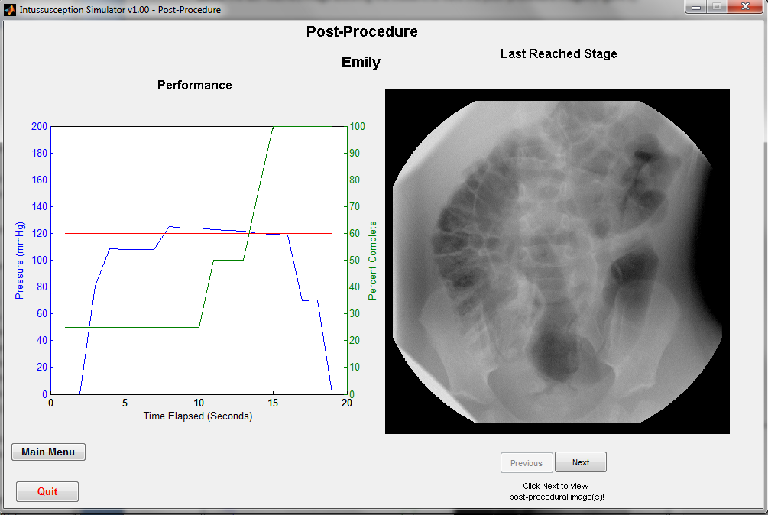

Figure : Post Procedure Window with Images

The buttons under the “Last Reached Stage” image allow the student to cycle through all available post-procedure images (Figure 6). The student can always return to the image of the last stage at any time by clicking the “previous” button.

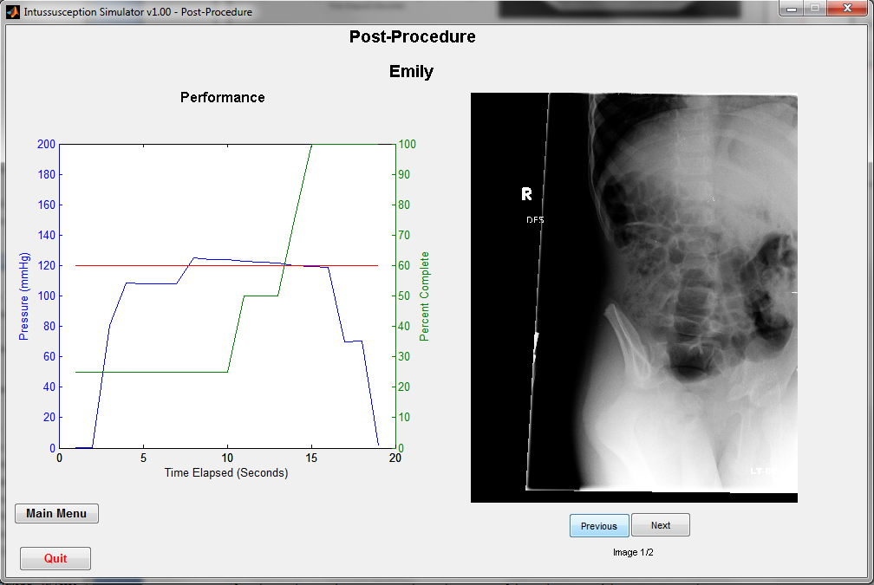

Figure : Viewing Post-Procedure Images

After the student and instructor evaluate the course of the reduction and the instructor makes any teaching points that need to be made, the student can either return to the Main Menu by clicking the “Main Menu” button, or exit the program by clicking the “Quit” button.

Why Is It Not Starting!? – Troubleshooting:

First of all, make sure that all tubes and wires are plugged in appropriately.

Potential problems:

1. Pressing the space bar does not change the image.
   1. Make sure that the mouse cursor on the screen is over the fluoroscopic image and click once on the image. This error may occur if a display setting is checked or unchecked during the procedure or if the mouse is clicked outside of the simulator window, deselecting the window.
2. The Program displays a sensor error message upon starting the simulator from the pre-procedure window.
   1. Make sure the pressure sensor is powered on and plugged in to the computer.
3. A case from the startup screen will not load (an error message appears)
   1. This issue will only occur if the selected case file is incomplete or corrupted. Reinstalling the case file from the source will fix this problem. Contact [intussusception.simulator@gmail.com](mailto:intussusception.simulator@gmail.com) for a current copy of the case and for help installing it.
4. The pressure on the insufflator is not the same as the pressure that the manometer is measuring. What gives?
   1. In a closed system, the pressures would be identical. However, since the instructor creates a small air leak in the system with the control valve, there is a small difference in pressure. The program accounts for this with a “fudge factor.”

**If you encounter an issue that is not described above and prevents the simulator from working properly, please contact us at** [**intussuception.simulator@gmail.com**](mailto:intussuception.simulator@gmail.com)**.**

## Guidelines for the Instructor

The instructor plays a critical role in effectively educating the student about techniques for successful air reduction of intussusception. This manual includes a brief overview of the pathology, diagnosis, and treatment of intussusception, and we suggest that both the instructor and the student read the following references:

References for the student: General[25]; Taping and other “how-to’s”[1, 17]

References for instructor: General[2, 3, 9, 26]

However, the most important part of the simulation is the interaction between the student and the instructor, with the instructor sharing insights based on his or her experience with actual patients.

The simulator: The simulator consists of a computer and monitor, a doll (the simulated patient), and an insufflator device. There is separate tube with a control valve that the instructor will manipulate during the simulated reduction.

Note: **The procedure progresses more quickly when using this simulation device than it usually does in real life.** We found that student and instructor fatigue made a realistic time line impractical, and we therefore significantly shortened the time required for reduction to progress. However, the instructor can control how difficult it is for the student to reduce the intussusception by turning the knob on the instructor’s valve. The valve controls the leakage of pressure from within the device. Increasing the air leak makes it difficult for the student to maintain enough pressure to reduce the intussusception, and lengthens the simulation. If the simulation is progressing too quickly, a quick twist of the valve will release the pressure and provide an opportunity to discuss the reasons why a reduction may not be progressing. The valve should probably always be held at a point where there is slight air leak, such that the student has to be constantly pumping to keep the pressure at or about 120 mmHg. **Note:** The pressure the student sees registered on the insufflator will probably be slightly higher than the pressure showing on the manometer; this is because of the air leak. The computer accounts for this slight difference. It is also important to recognize that it is up to the instructor to teach the student about the “rule of three’s”, if they choose to do so. This is not built into the program.

Patients: The following is a list of the patients and their histories that you will see in the simulator, with the annotated images from each case.

1. Amy: 5 m/o girl, previously healthy, has been vomiting for 4 days, with 5 episodes of dark green emesis, now refusing feeds. She was initially inconsolable, but now she is lethargic with intermittent crying when drawing her legs up. Temperature 101, Pulse 140. She passed a bloody stool as you were about to place the catheter.   
   *Instructor’s notes:* The reduction starts normally, but it is likely that during the course of the procedure the student will see a fluoroscopic image demonstrating pneumoperitoneum, giving the instructor an opportunity to discuss the management of a tension pneumoperitoneum.

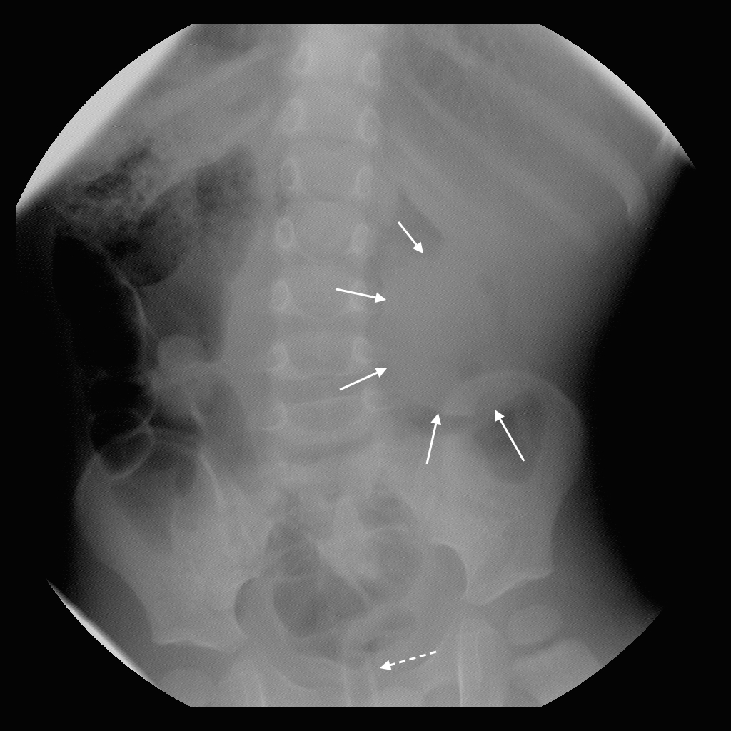

Amy – image 1. The mass of intussuscepted bowel is seen in the left upper quadrant (solid arrows). The rectal tube can be seen in the pelvis (dashed arrow).

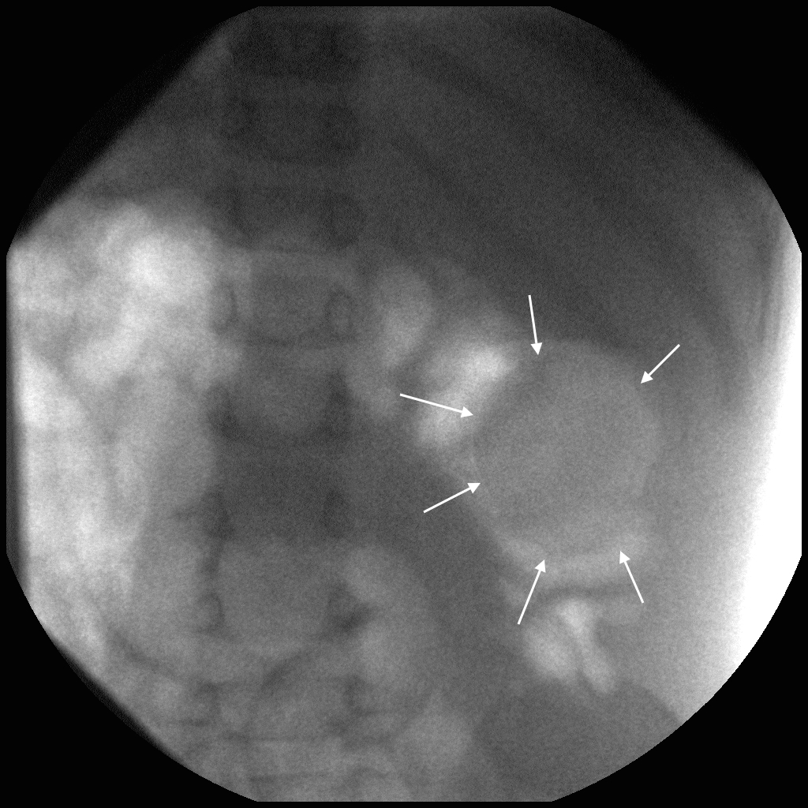

Amy – Image 2. The mass of intussuscepted bowel in the left upper quadrant remains present (solid arrows).

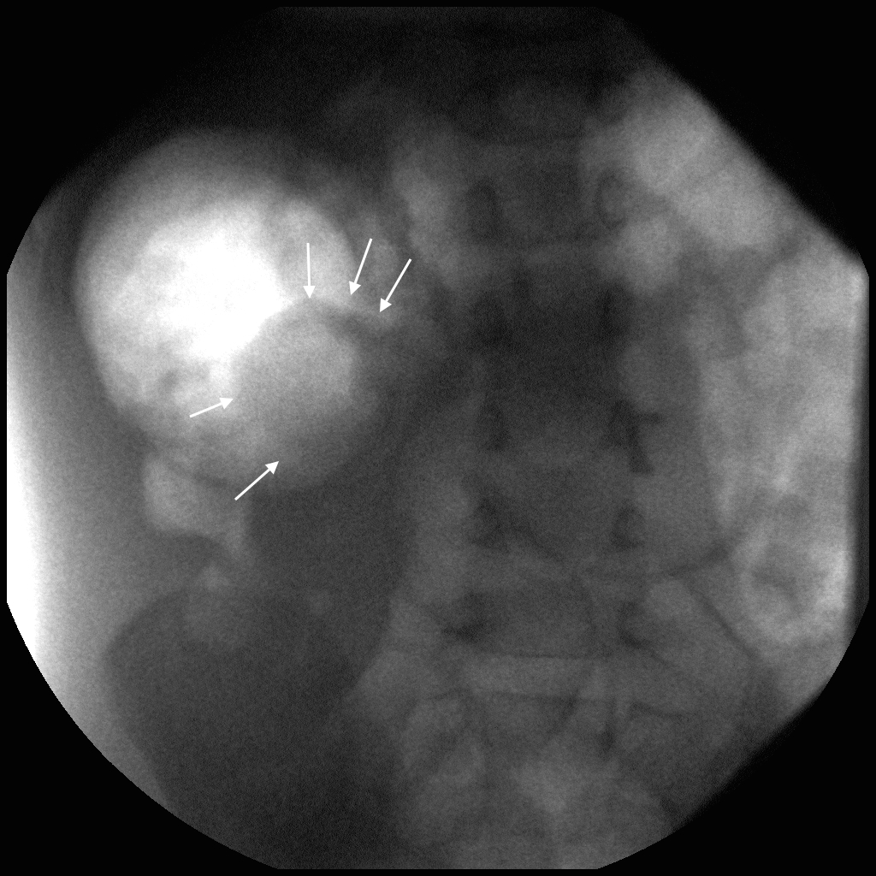

Amy – image 3. The intussusception has, with the application of increased intraluminal pressure, advanced to the right upper quadrant (solid arrows).

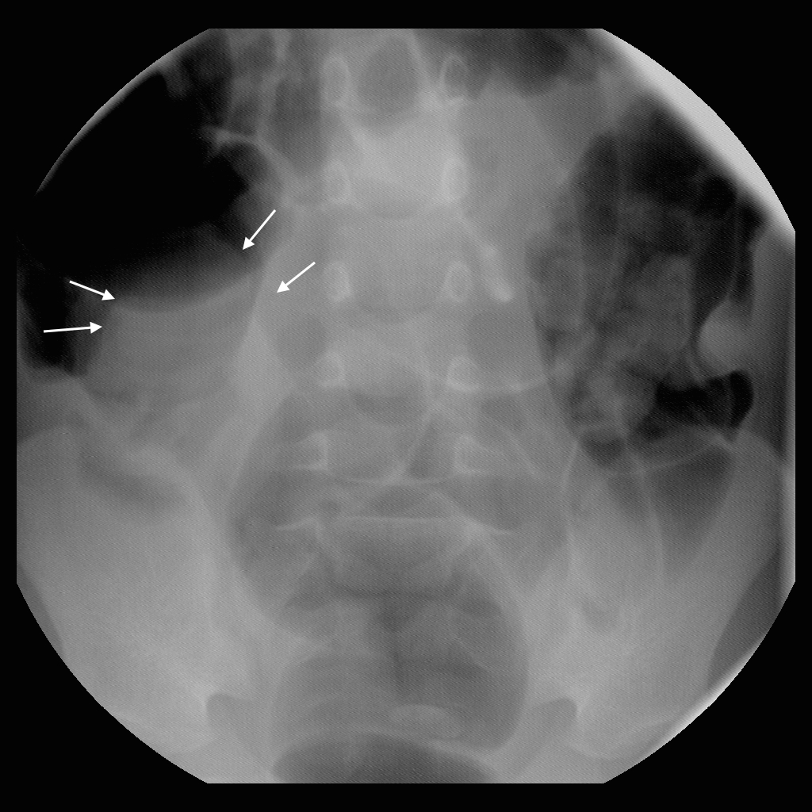

Amy – Image 4. The intussuscepted bowel remains in the right upper quadrant (solid arrows).

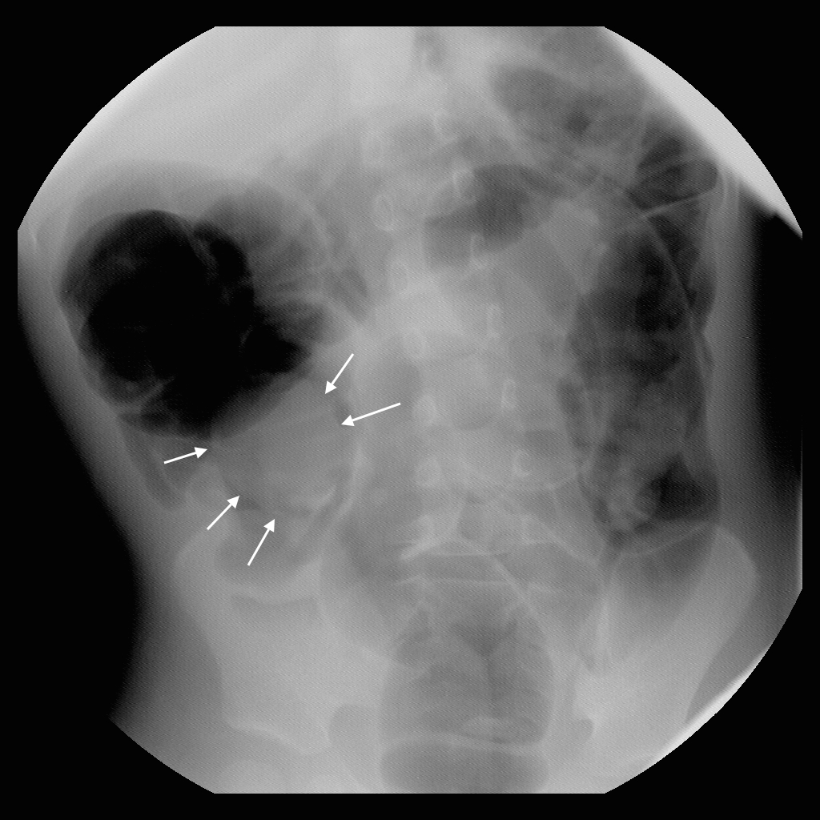

Amy – Image 5. The mass of intussuscepted bowel has advanced further toward the iliocecal valve, though it continues to protrude into the lumen of the cecum (solid arrows).

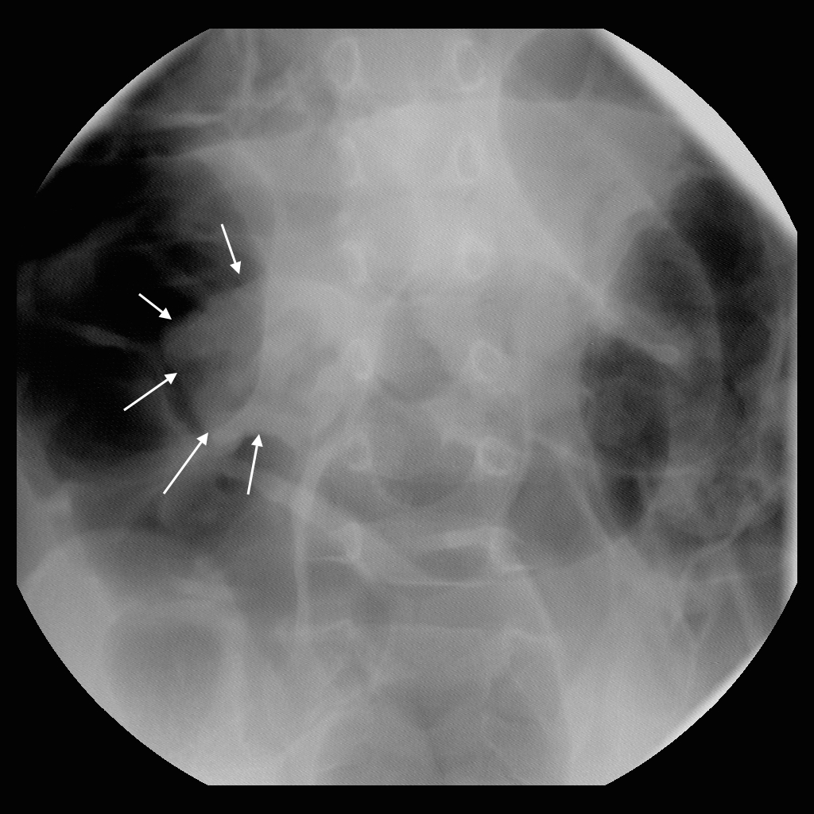

Amy – image 6. The intussusception continues to protrude into the cecum (solid arrows).

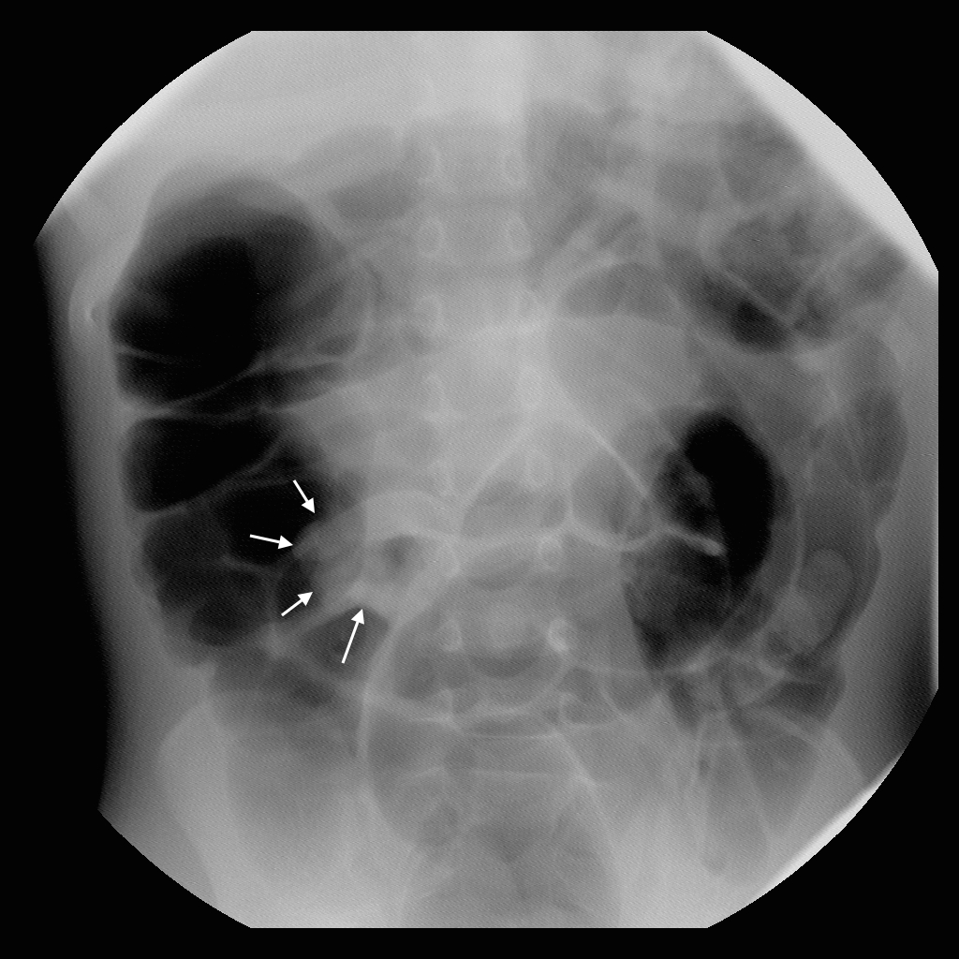

Amy – image 7. The mass is almost completely reduced (solid arrows).

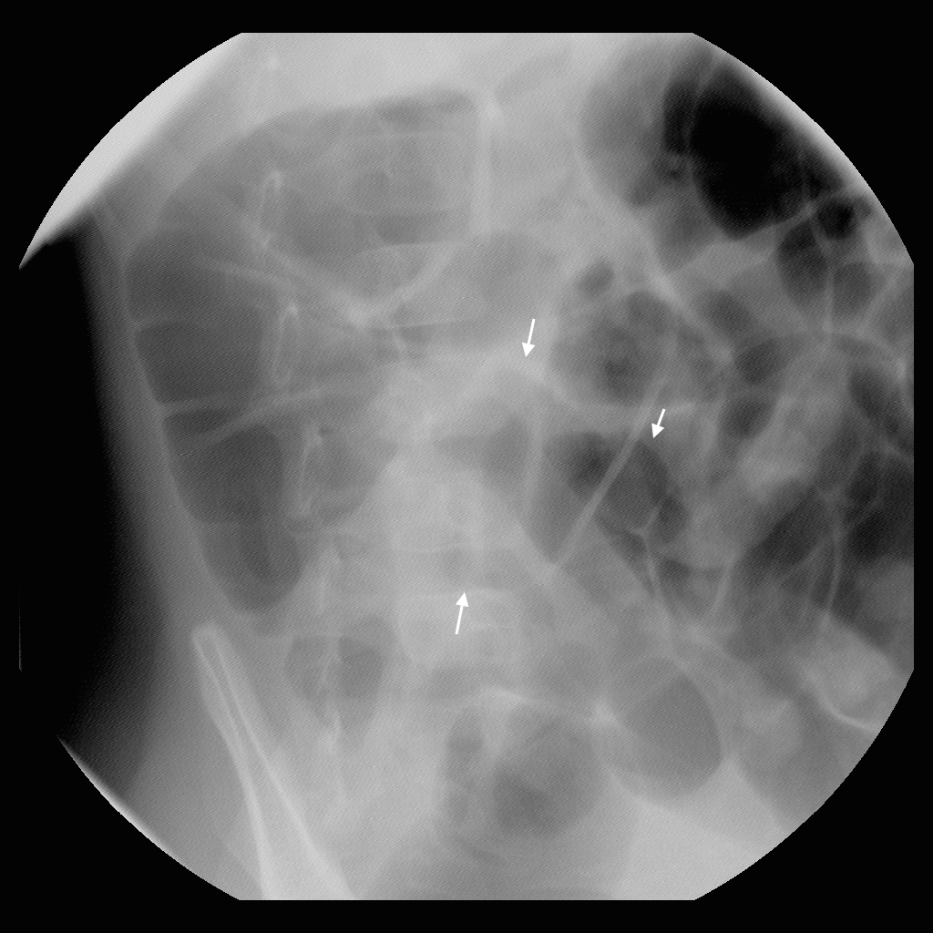

Amy – image 8. The mass has reduced, and there are multiple air-filled loops of small bowel in the mid abdomen (solid arrows).

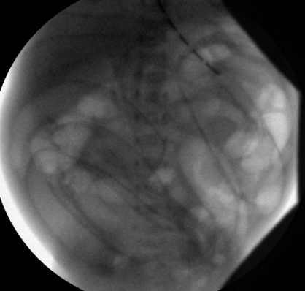  
**Figure 7:** The image demonstrating free air. The student should recognize this complication immediately and send for the surgeon.

1. Brandon: Previously healthy 4 m/o boy with abdominal pain for 2 days. An outside ED discharged him yesterday with “viral gastroenteritis”, and the parents were told it would resolve on its own. Now he is fussy and drowsy, with a soft, mildly distended abdomen and a large, firm, palpable, tender mass in the LUQ. Bilious emesis was observed in the Emergency Department. Temperature 101.5, Pulse 160. The patient is crying but there are no tears and his mucous membranes are dry. Rectal examination is positive for bright red blood. WBC 22.1K HCT 45.   
   *Instructor’s Notes:* This is likely to be a frustrating case for the student, since the intussusception is impossible to reduce; it will progress to a certain point, then fail to progress further. The student needs to realize that, though failure to reduce the intussusception is uncommon, it does happen. The concluding image demonstrates a nonreducible intussusceptum found in the transverse colon. During surgery, a manual intra-operative attempt at reduction was able to move the intussusceptum to the cecum, but further reduction resulted in significant damage to the bowel wall and perforation, so ileo-colic resection with primary anastamosis was performed. See Figures 8 and 9 for representative images from the preprocedure images and the reduction.

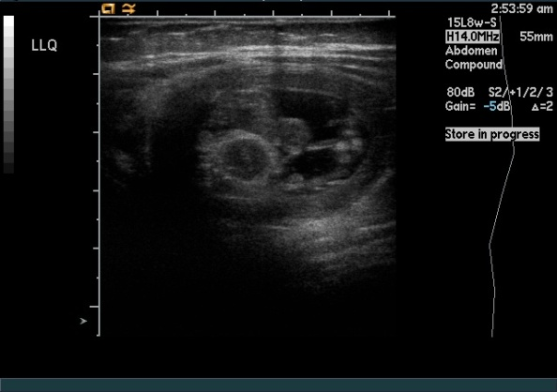 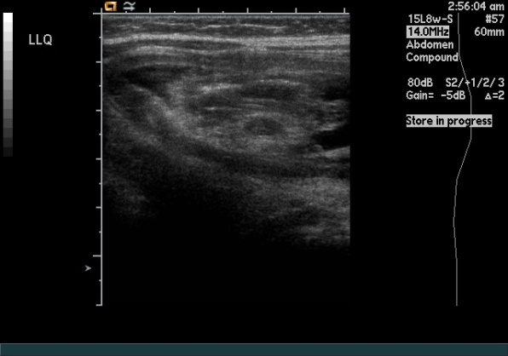

**Figure 8:** Photomontage of Brandon’s ultrasound images demonstrating an intussusception in the LLQ.

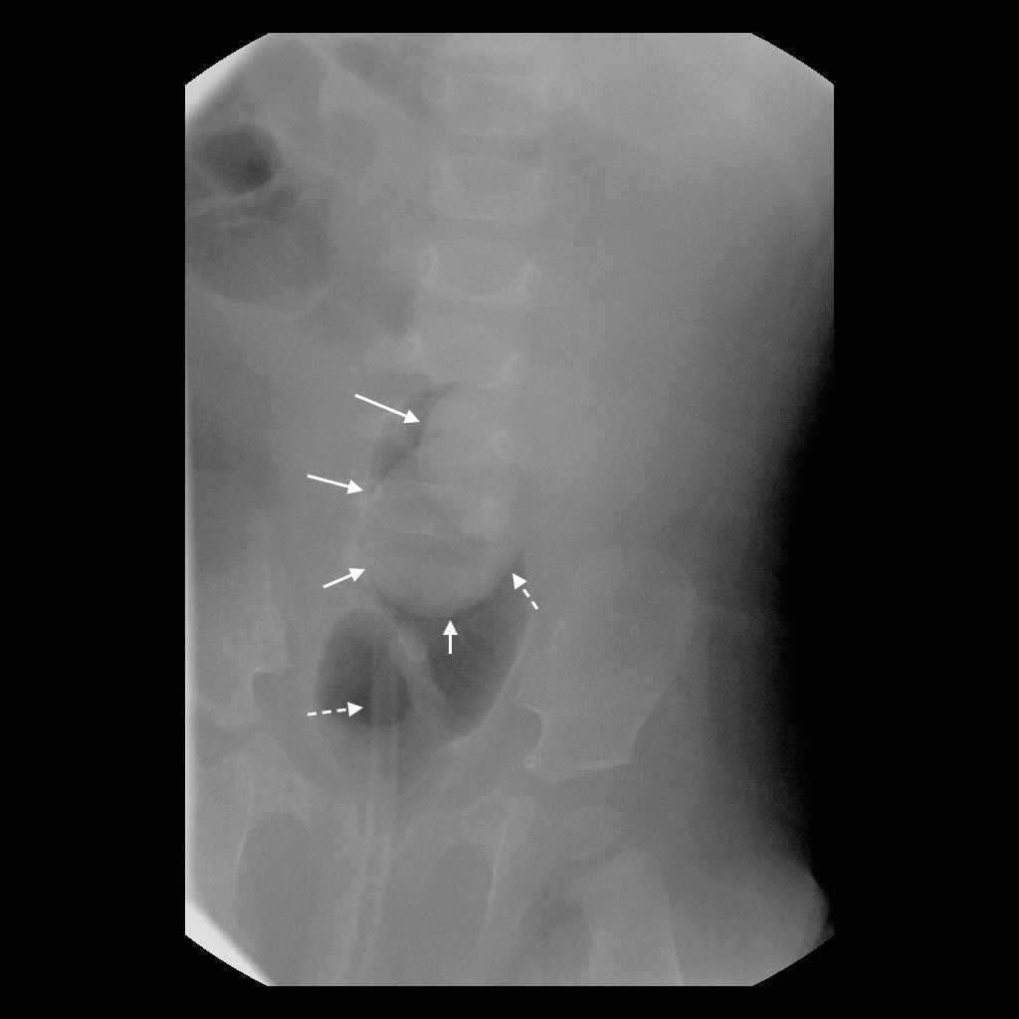

Brandon – image 1. The mass of intussuscepted bowel extends nearly to the rectum (solid arrows). The rectal tube is in place (dashed arrow).

The solid arrows in the following images demonstrate the mass of bowel slowly advancing toward the cecum.

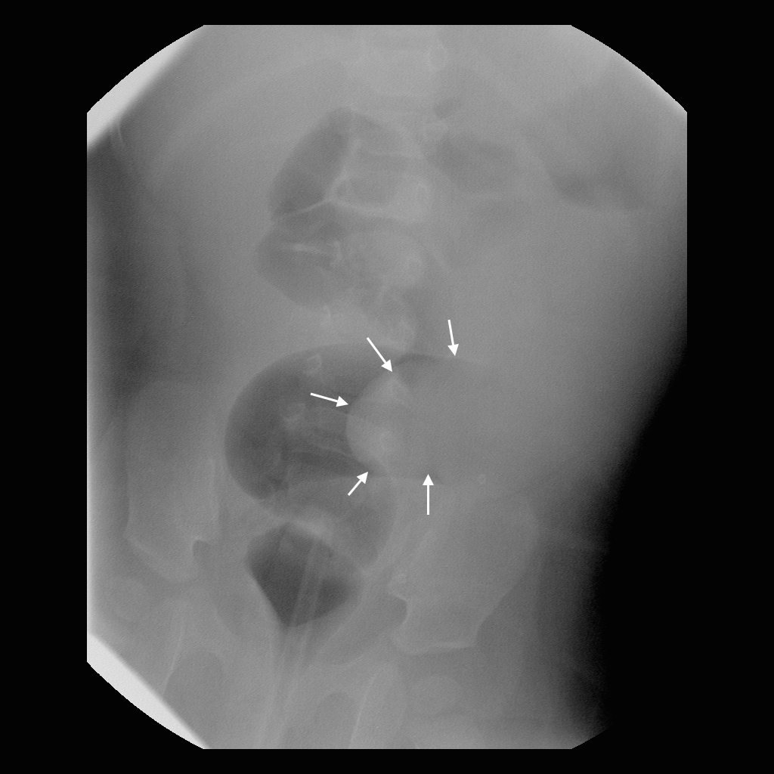

Brandon – image 2.

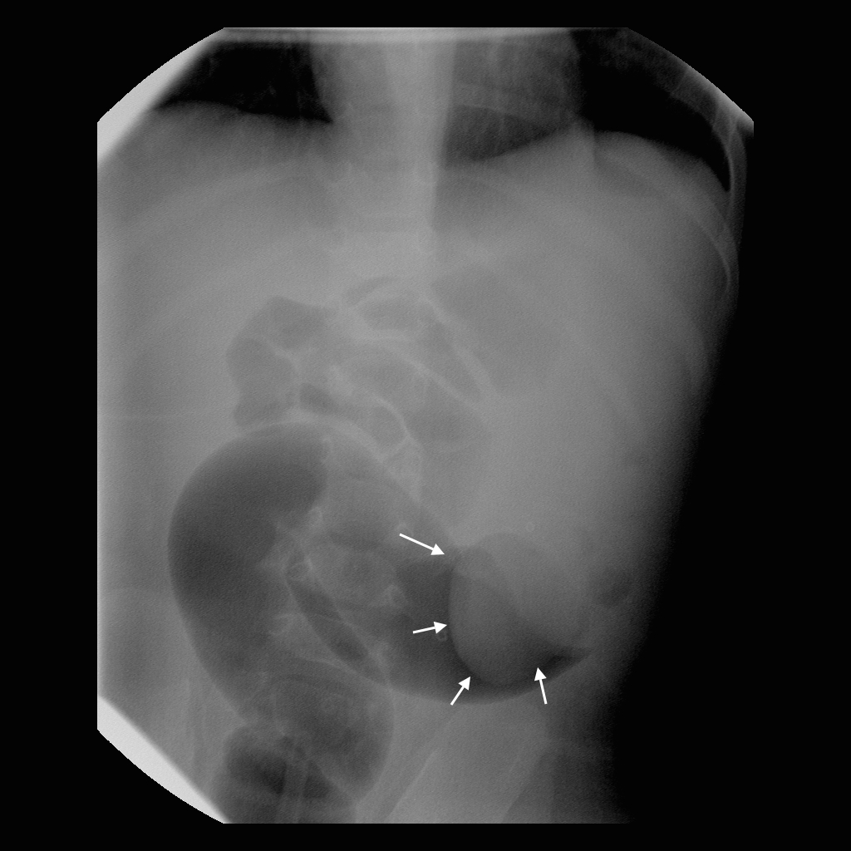

Brandon – image 3.

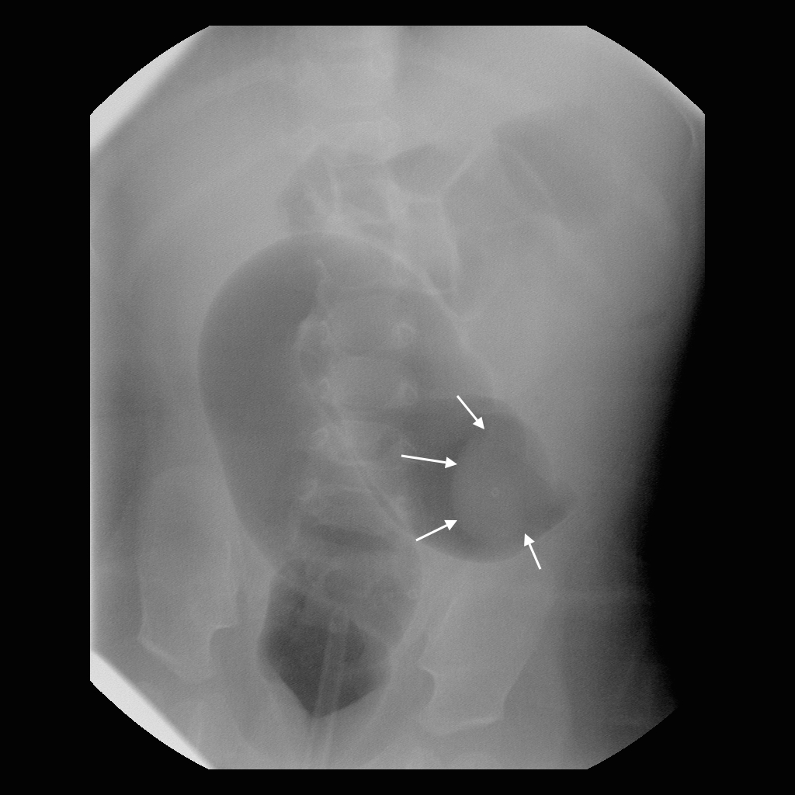

Brandon – image 4.

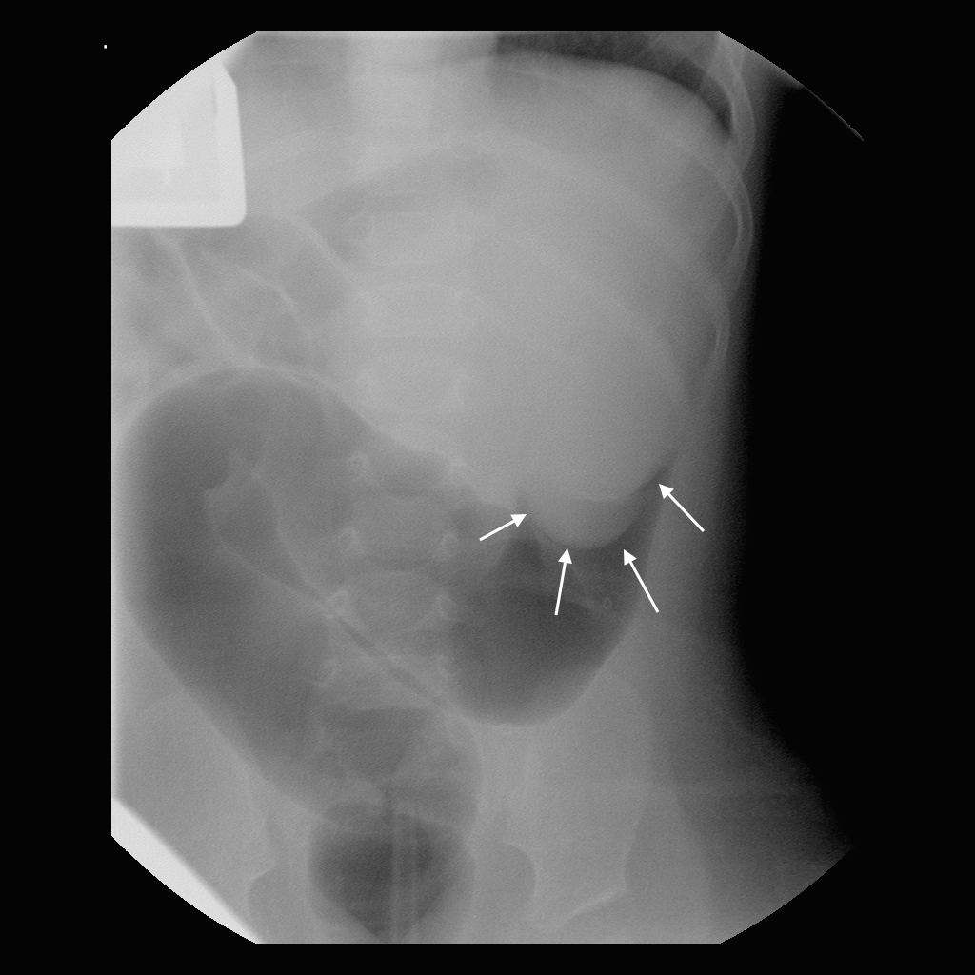

Brandon – image 5.

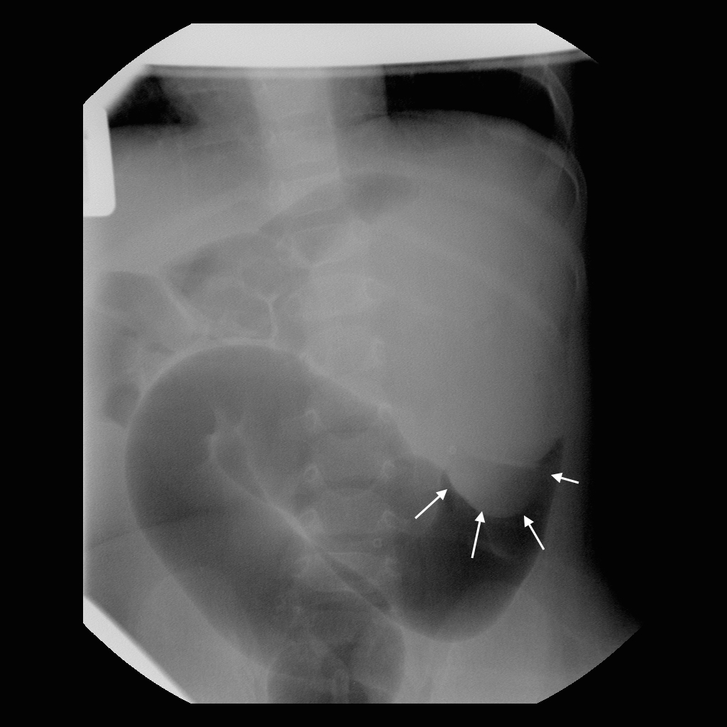

Brandon – image 6.

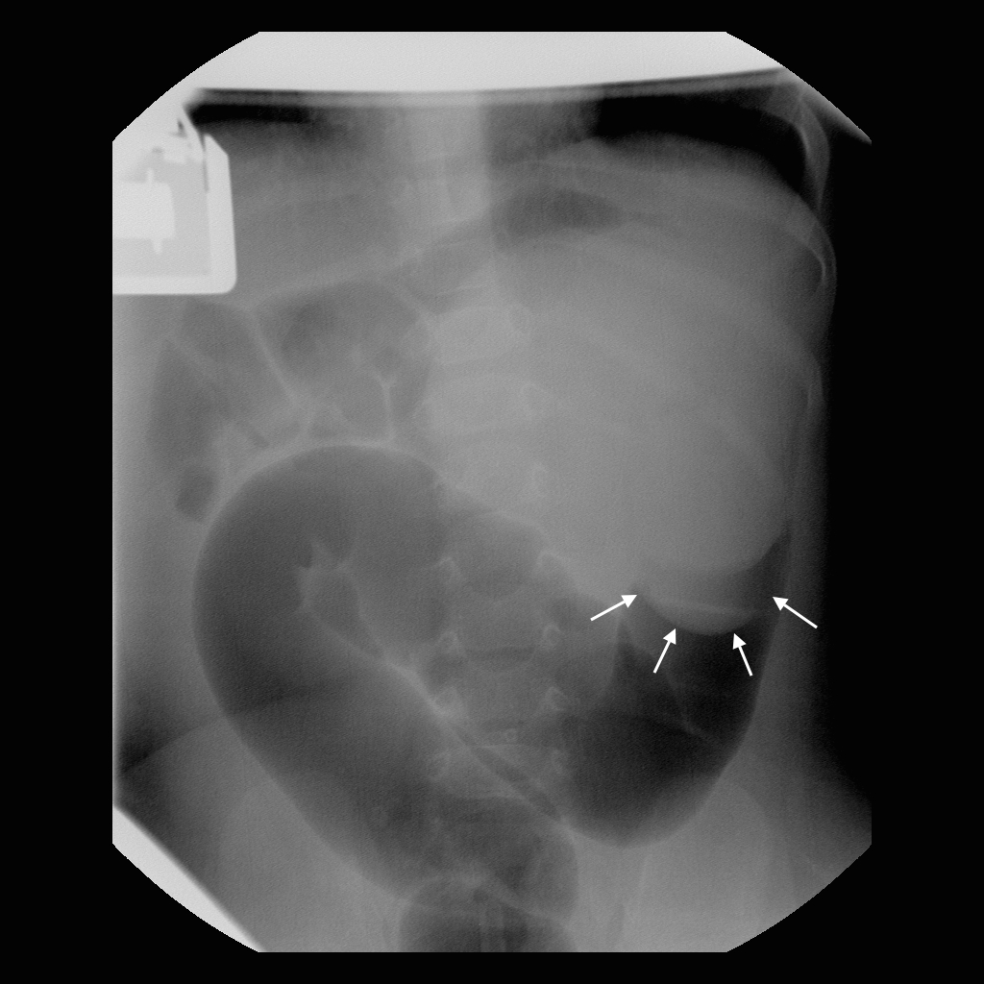

Brandon – image 7.

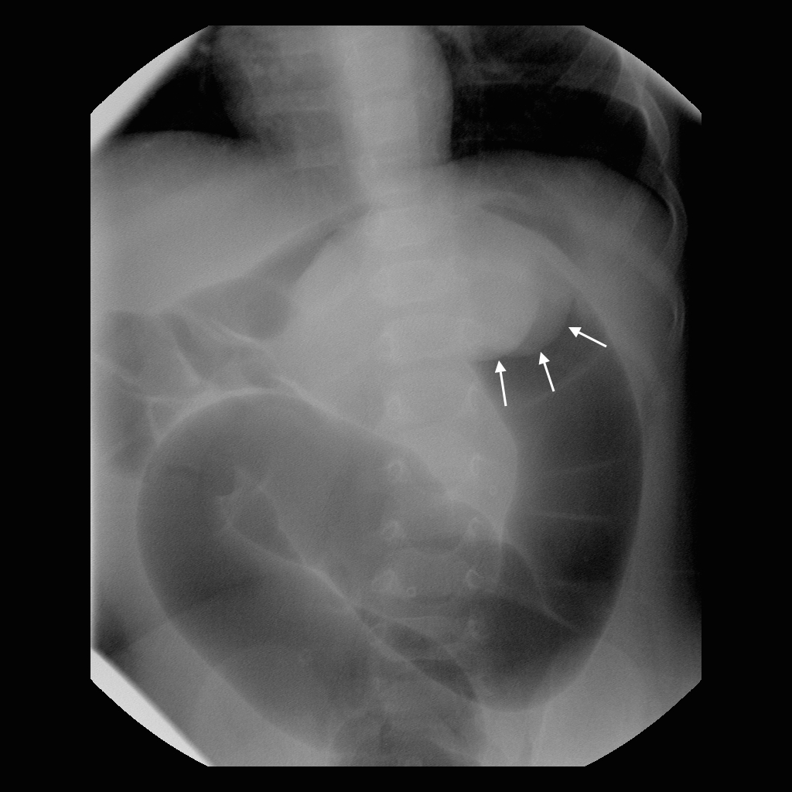

Brandon – image 8.

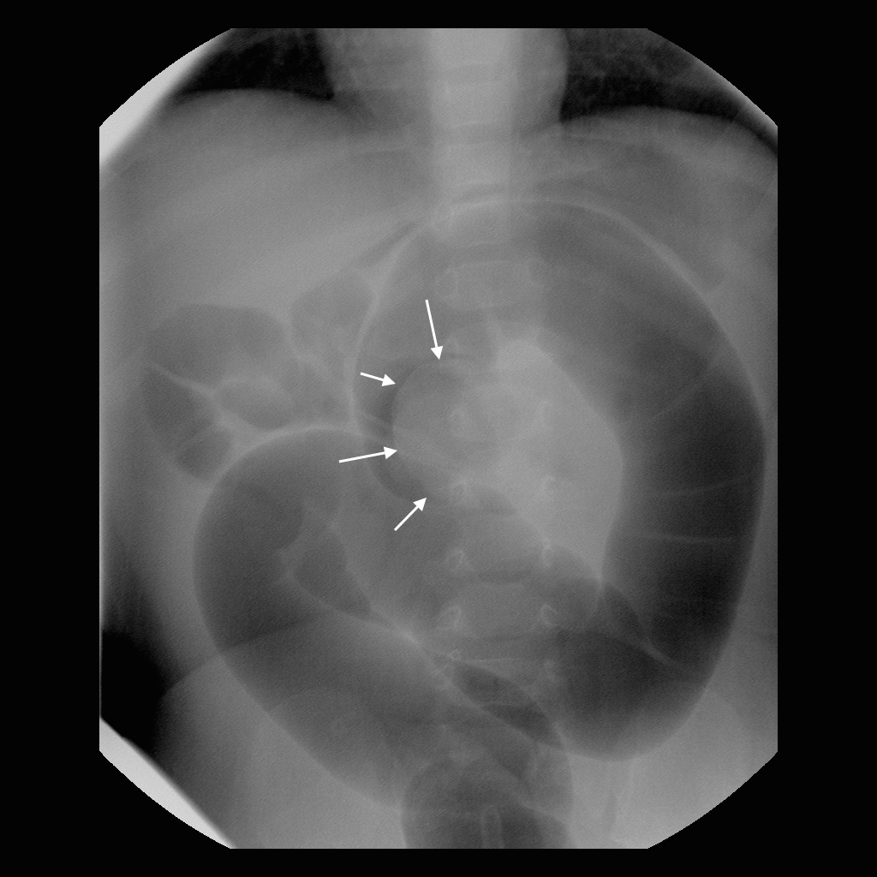

Brandon – image 9.

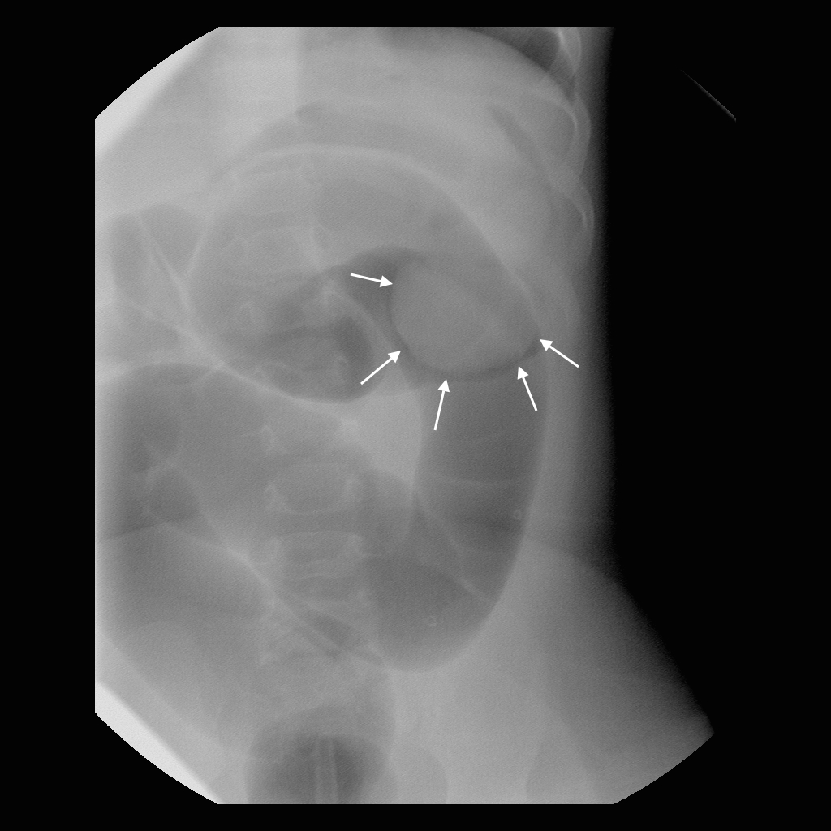

Brandon – image 10.

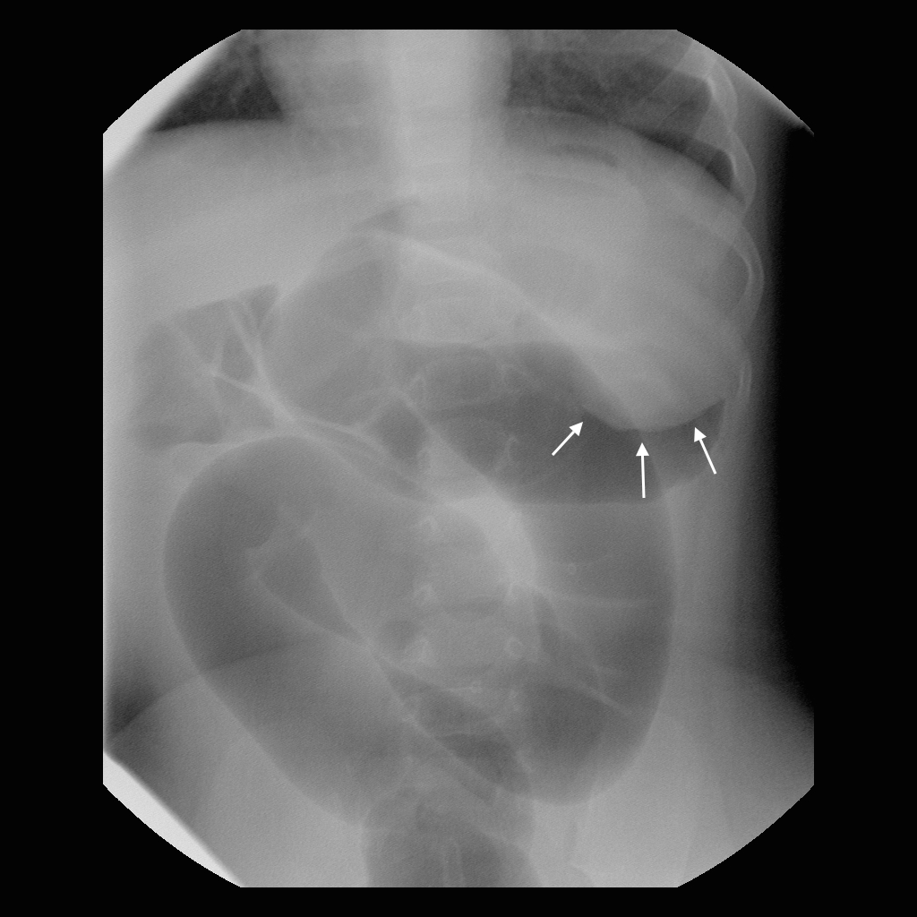

Brandon – image 11.

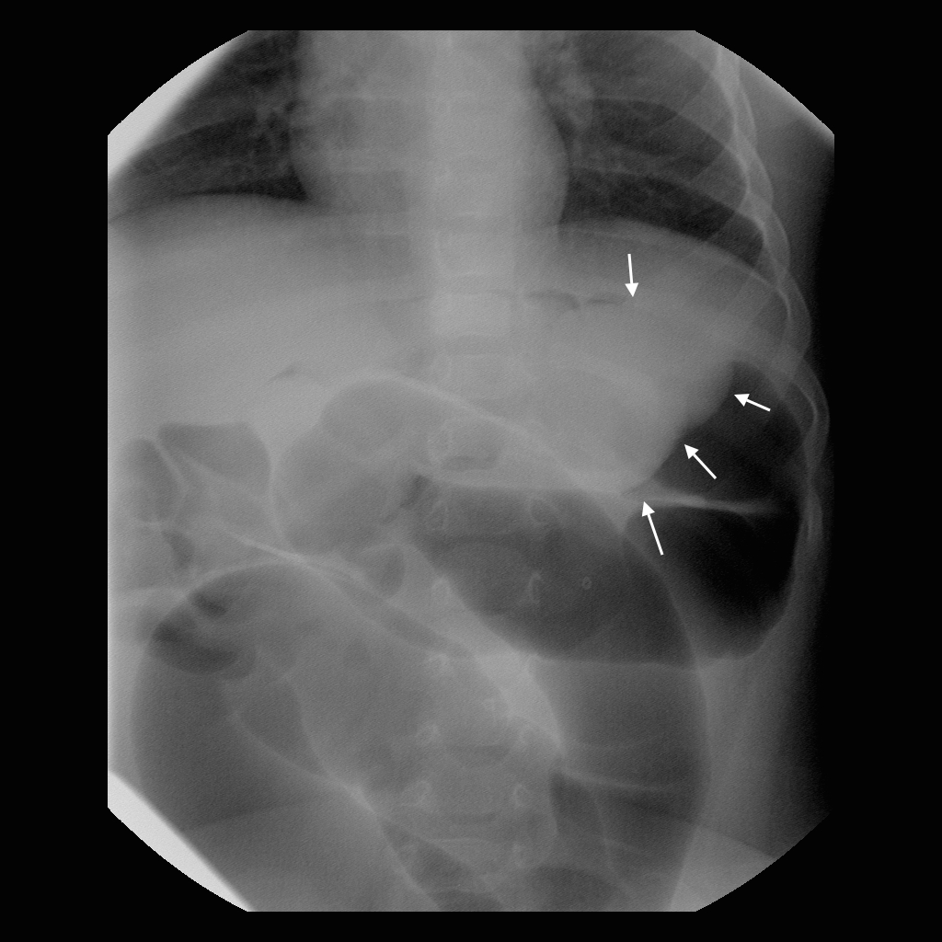

Brandon – image 12.

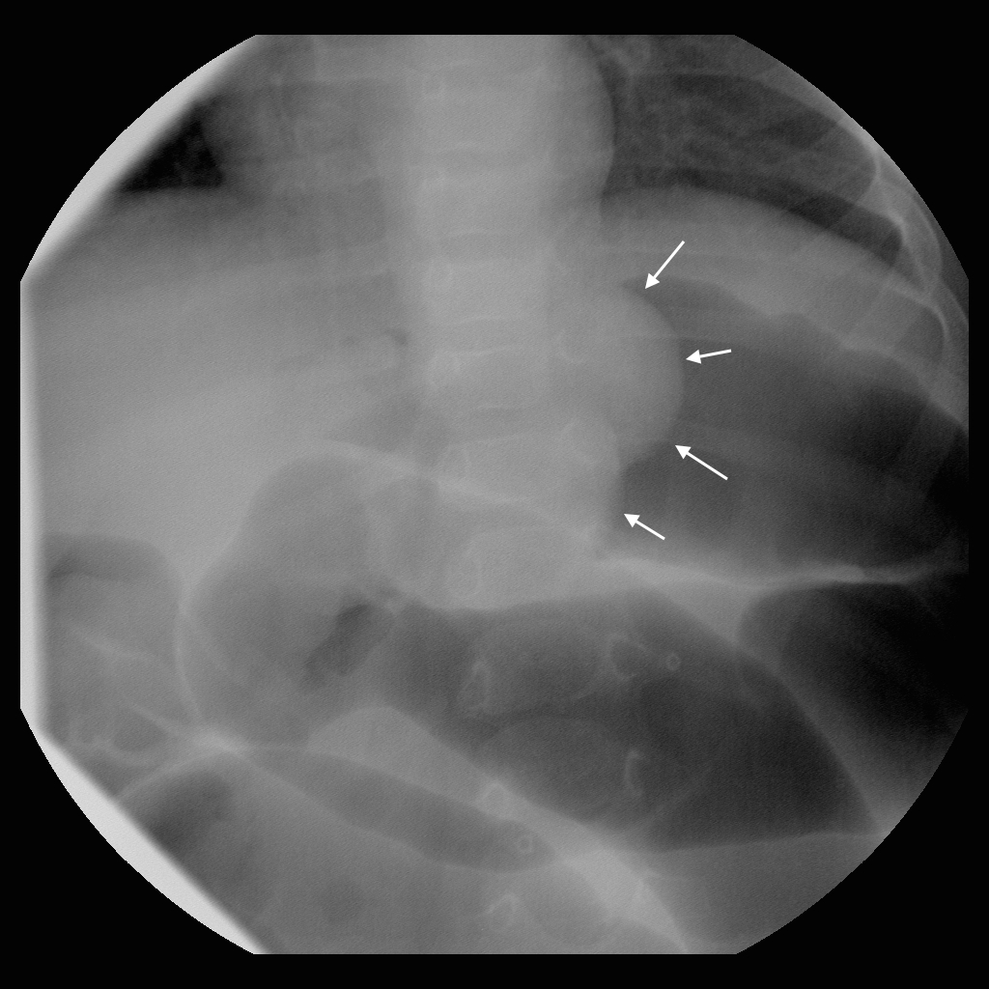

Brandon – image 13.

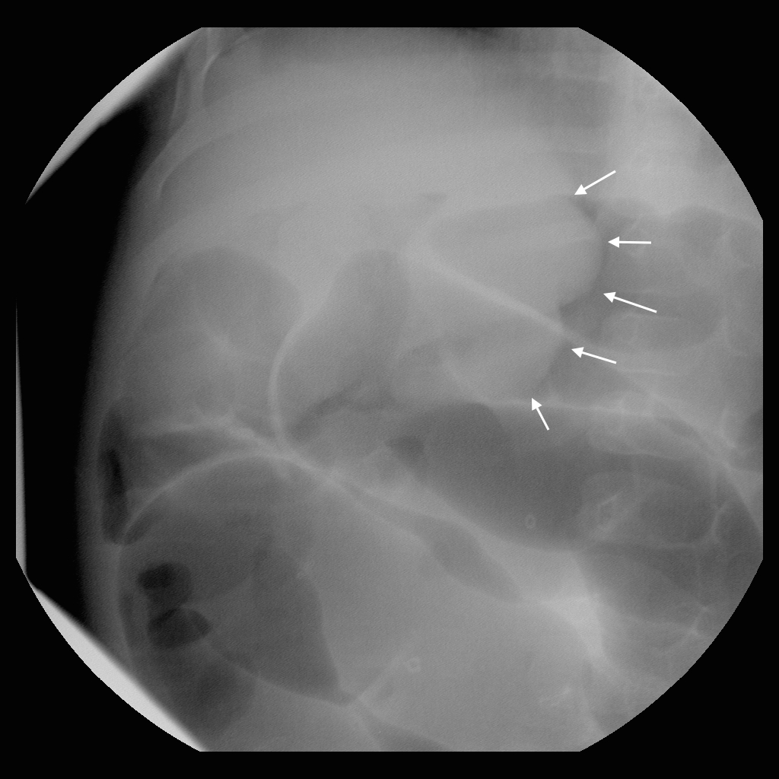

Brandon – image 14.

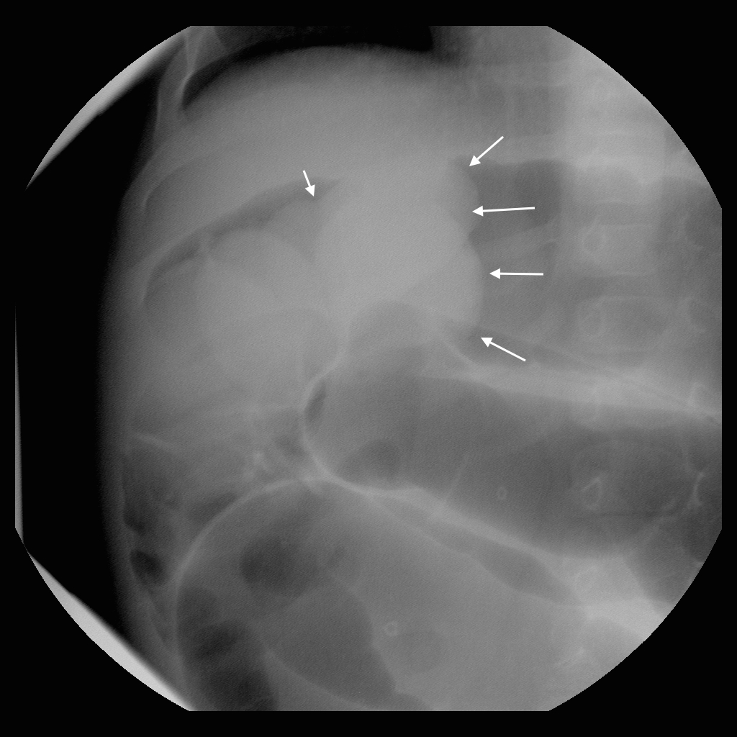

Brandon – image 15.

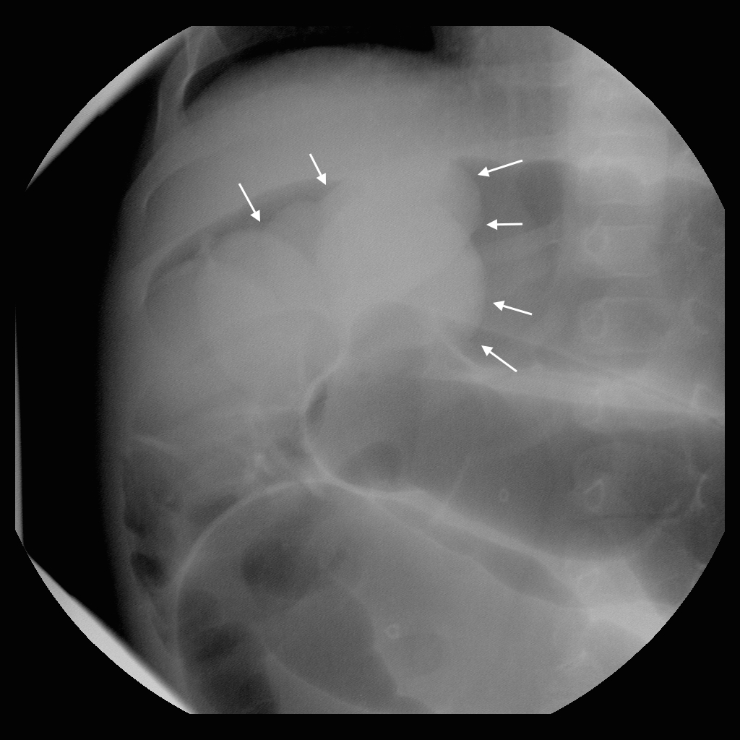

Brandon – image 16.

1. Charlotte: 7 m/o girl who was healthy until the day before admission when she developed bilious vomiting. No bowel movement for 36 hours. Temperature 99. Pulse 120. She is irritable but consolable and seems to be having episodic abdominal pain. Her abdomen is mildly distended.   
   *Instructor’s Notes:* This is a relatively easy intussusception to reduce. See Figure 10 for representative images. The clinical presentation of bilious emesis provides the opportunity to discuss more unusual manifestations of intussusception (and important differential considerations).

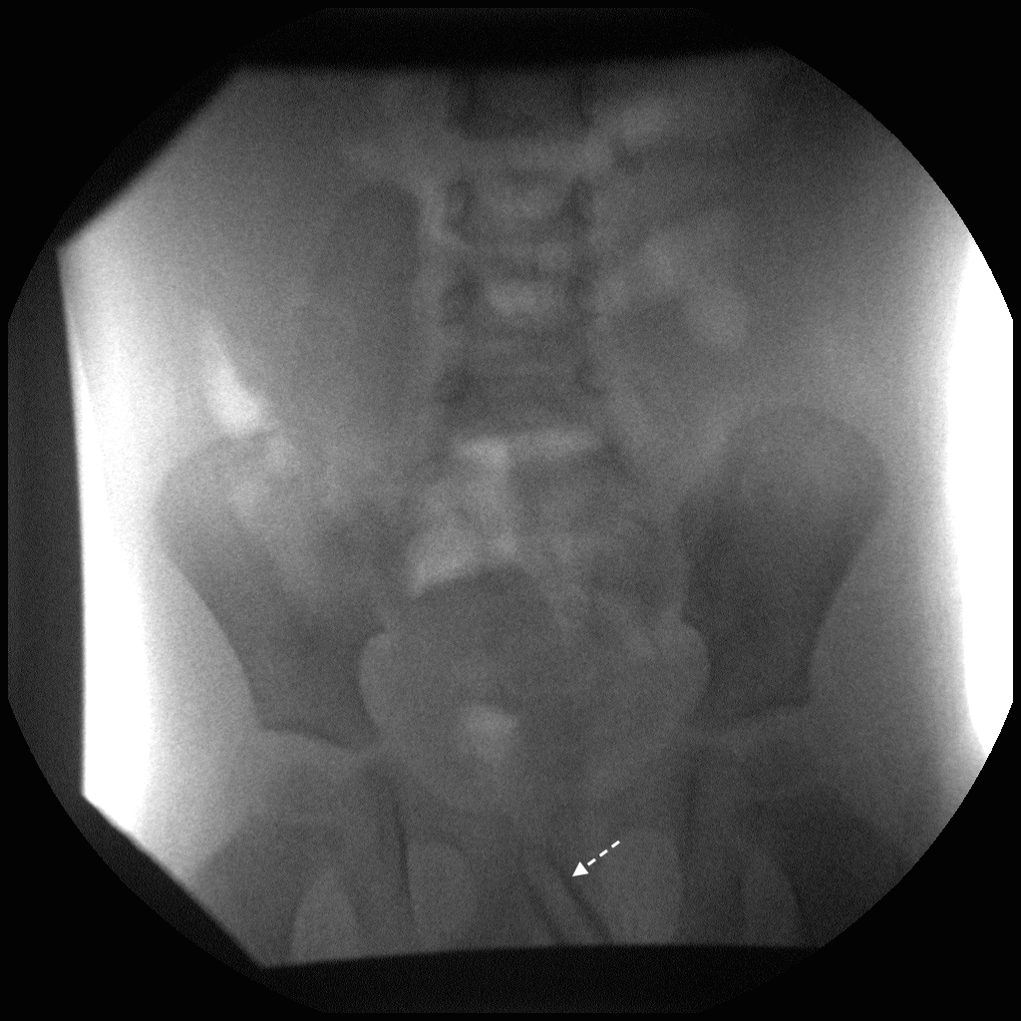

Charlotte – image 1. The rectal tube is in place (dashed arrow).

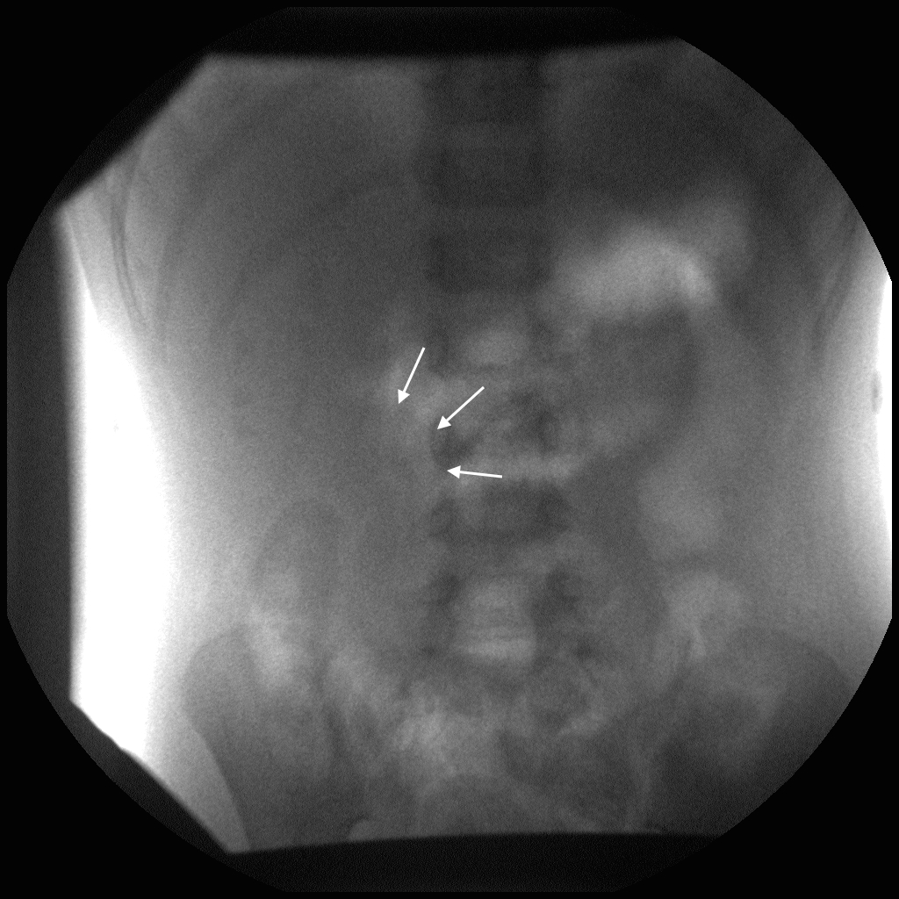

Charlotte – image 2. The intussusception is admittedly subtle on this image, but there is a cutoff of the colon in the right upper quadrant.

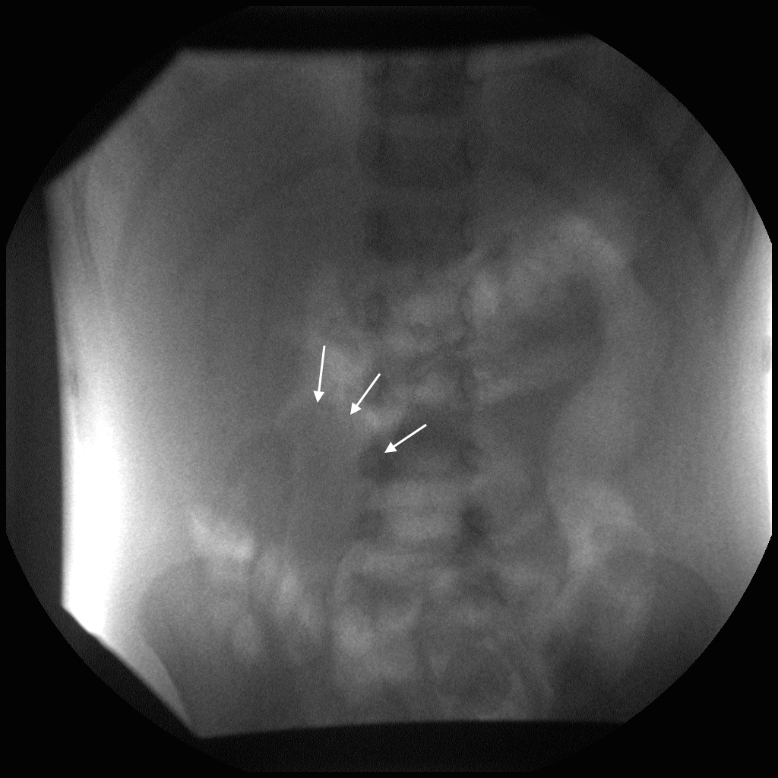

Charlotte – image 3. The intussusception is outlined with the solid arrows in this and the subsequent images.

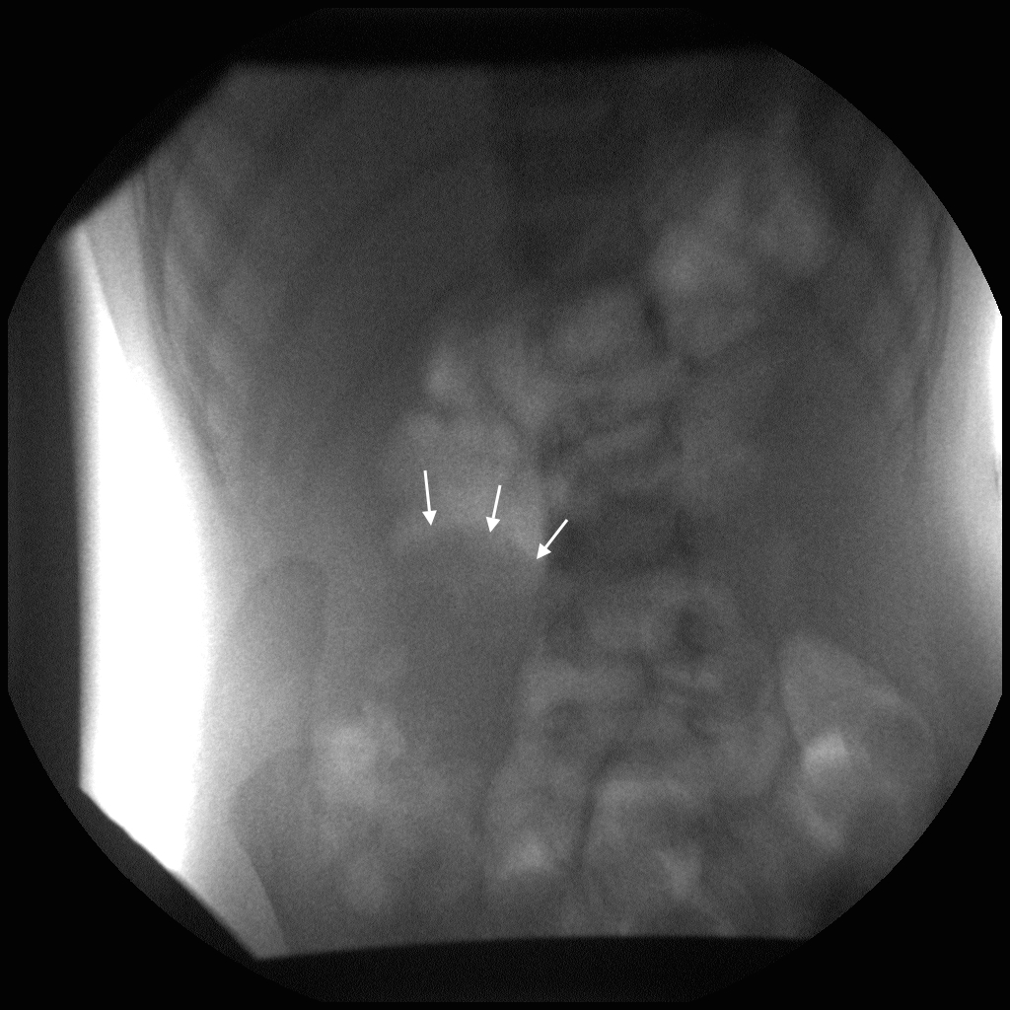

Charlotte – image 4.

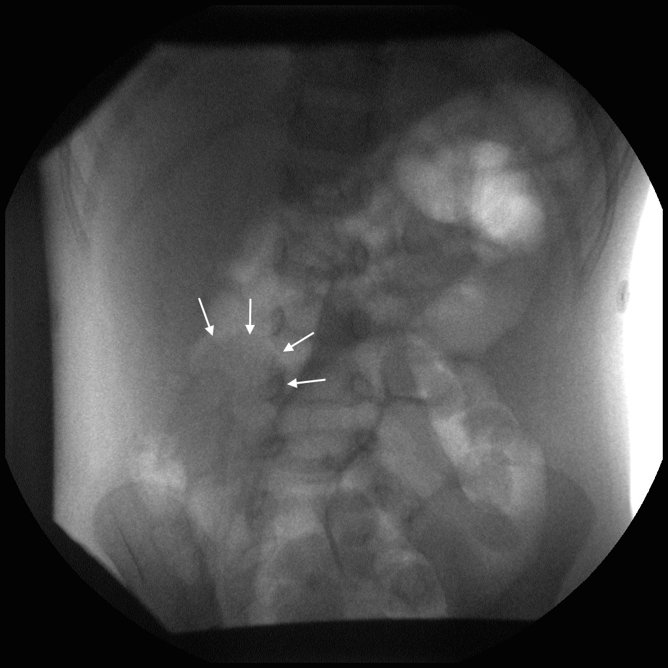

Charlotte – image 5.

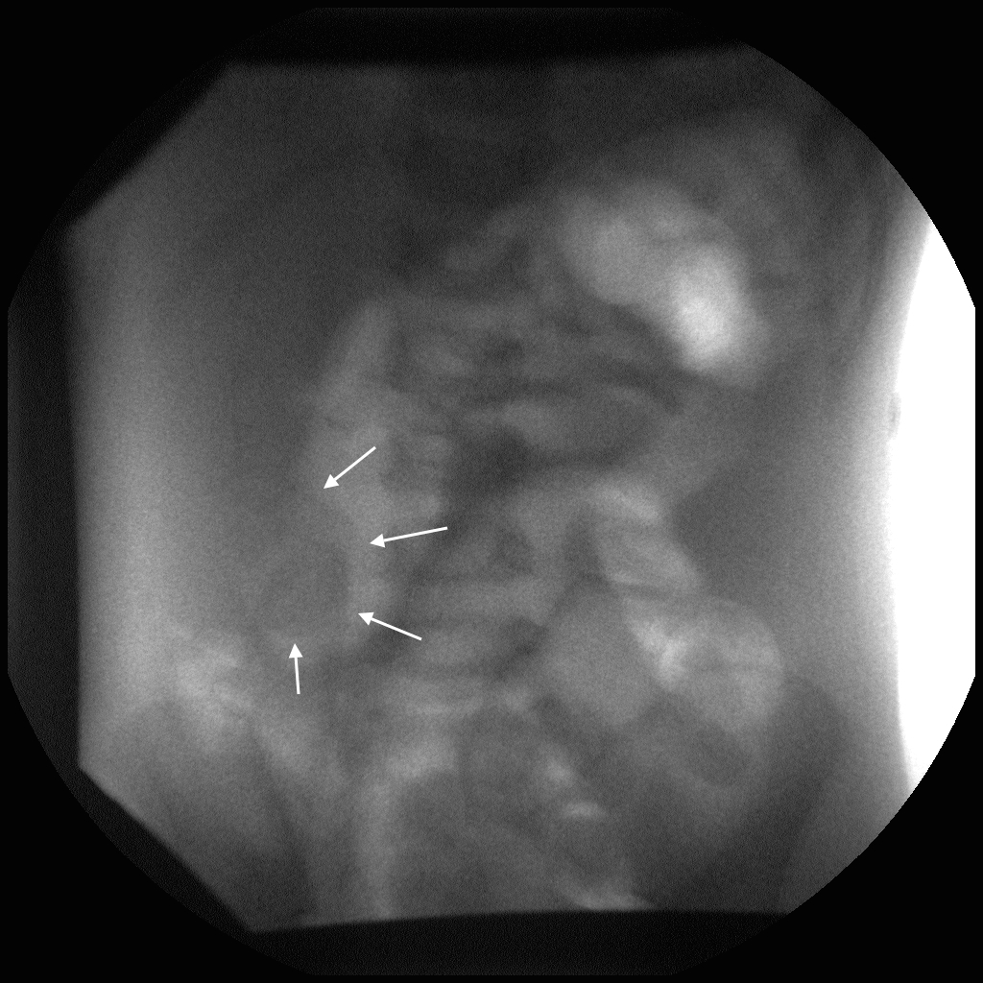

Charlotte – image 6.

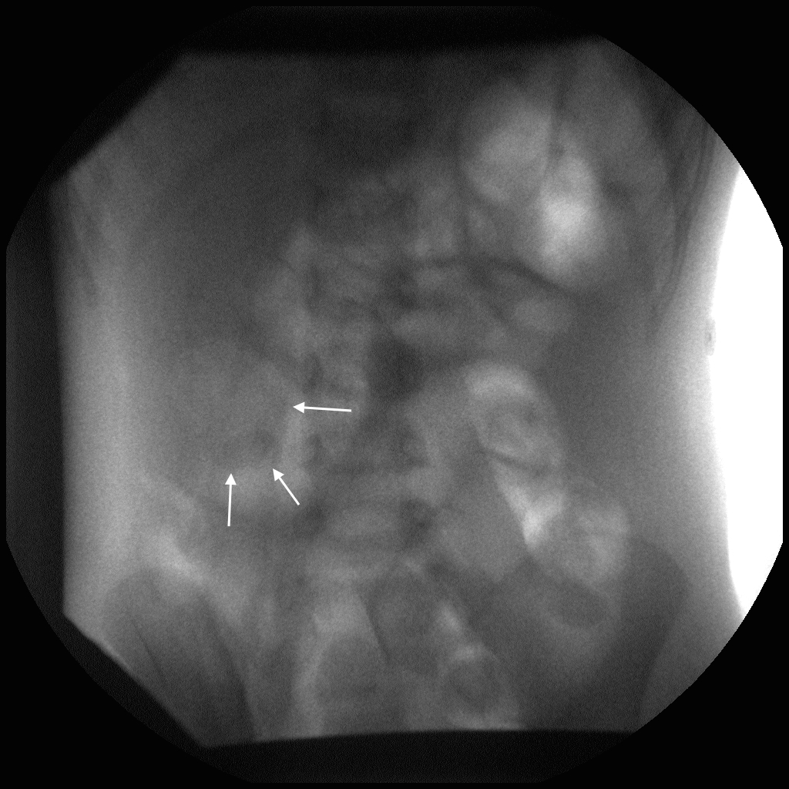

Charlotte – image 7.

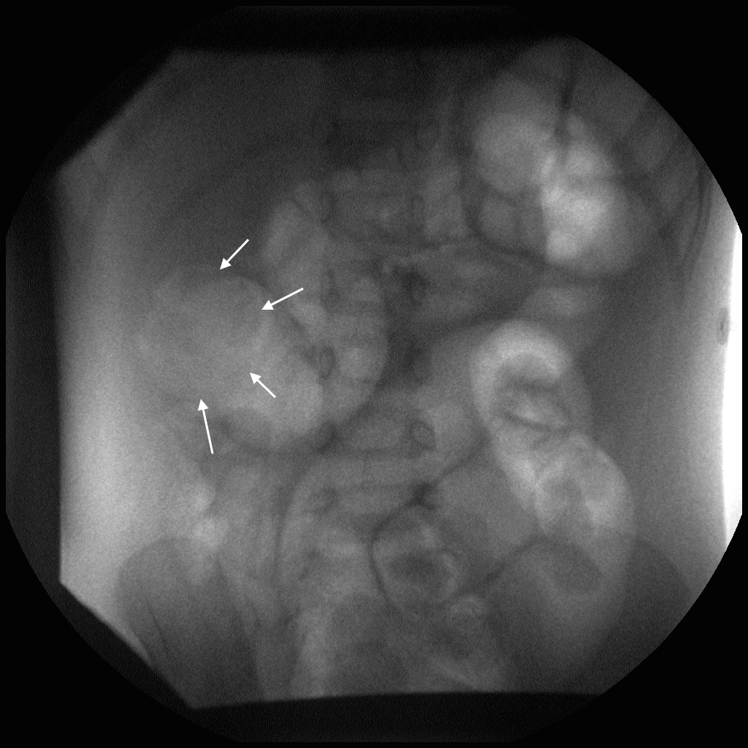

Charlotte – image 8.

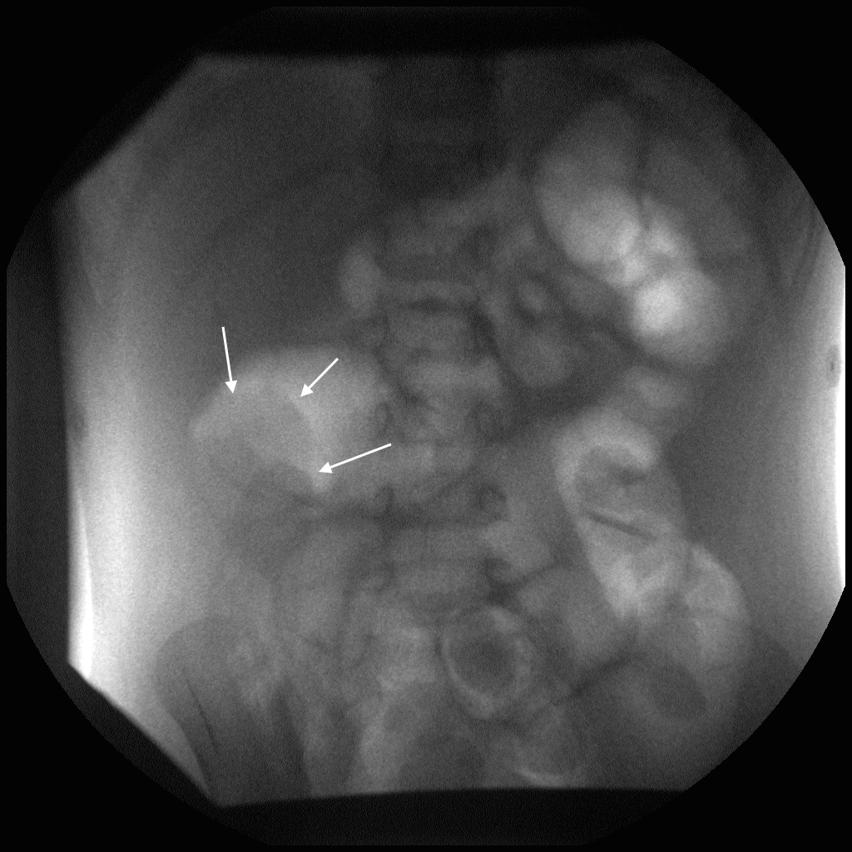

Charlotte – image 9.

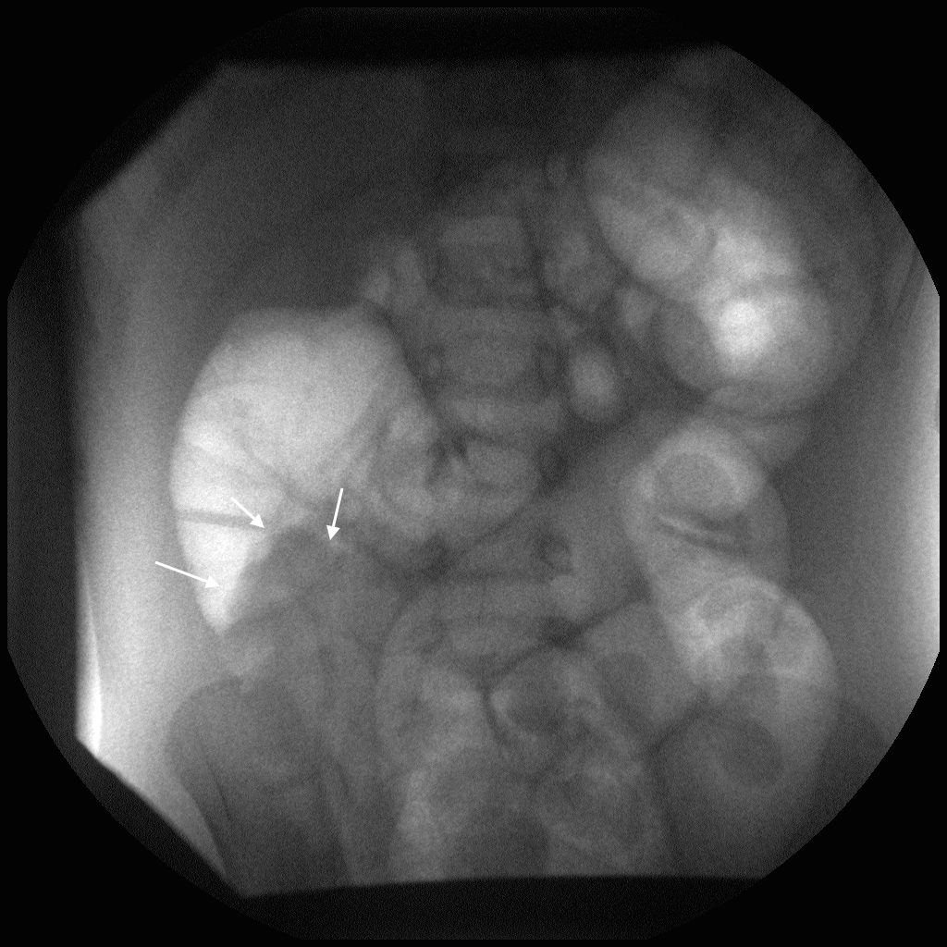

Charlotte – image 10.

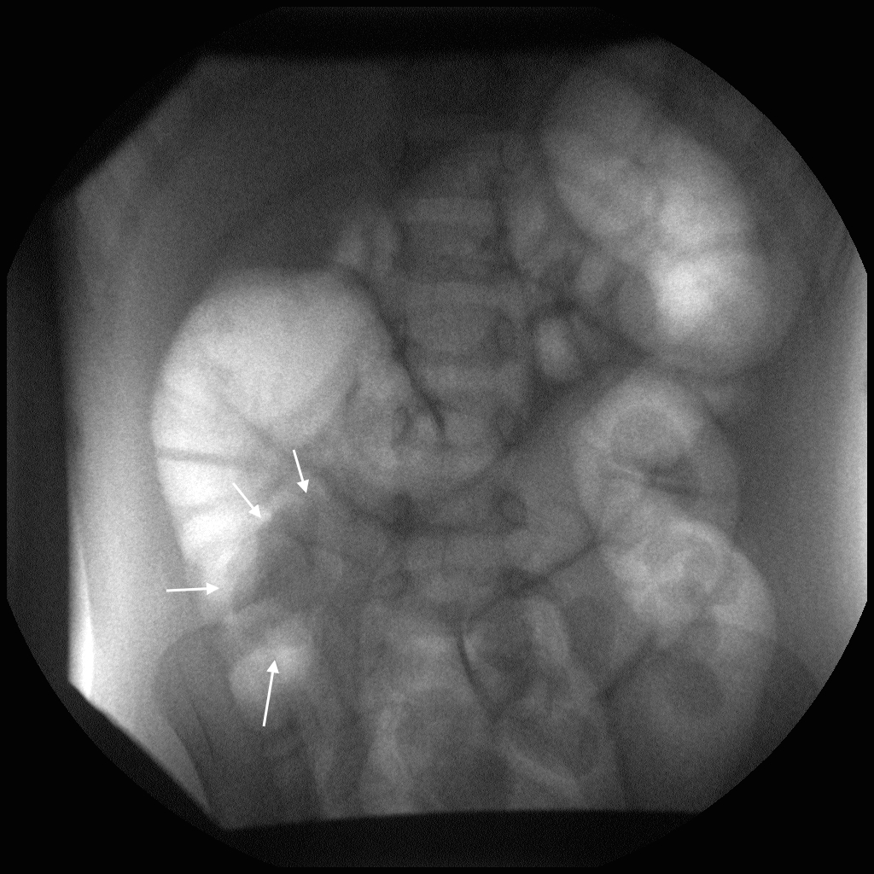

Charlotte – image 11.

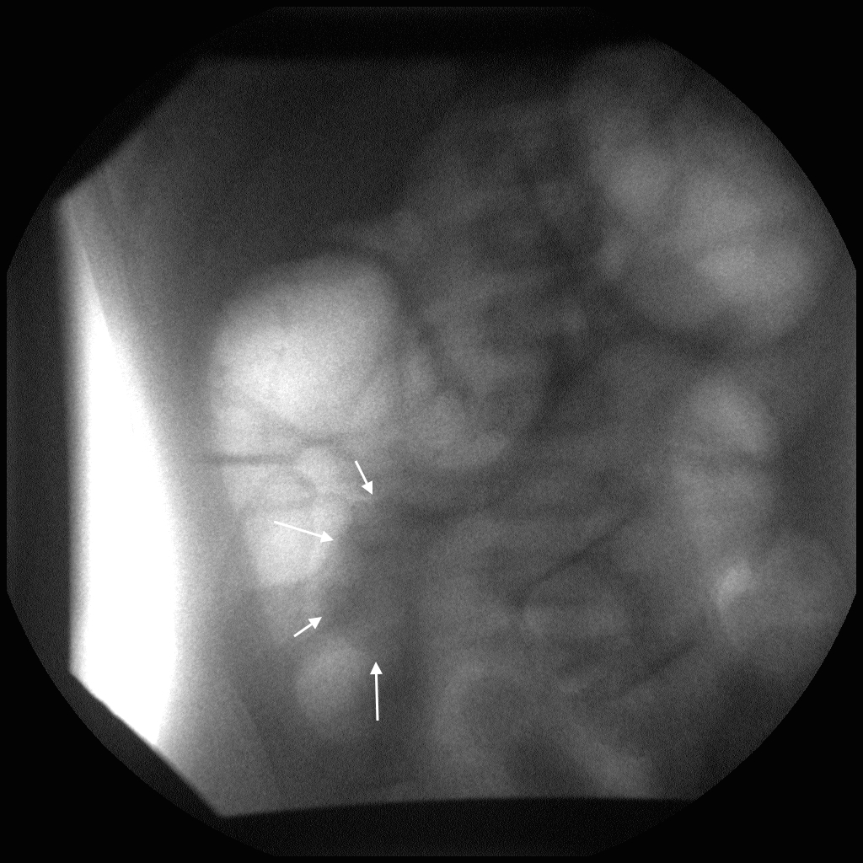

Charlotte – image 12.

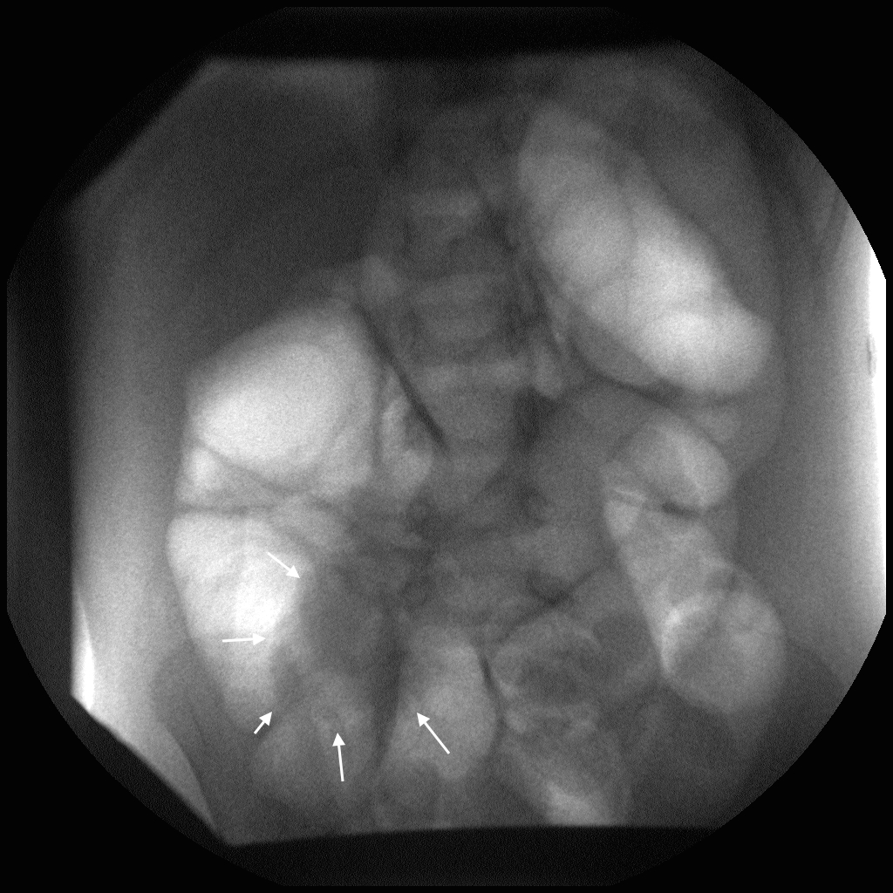

Charlotte – image 13.

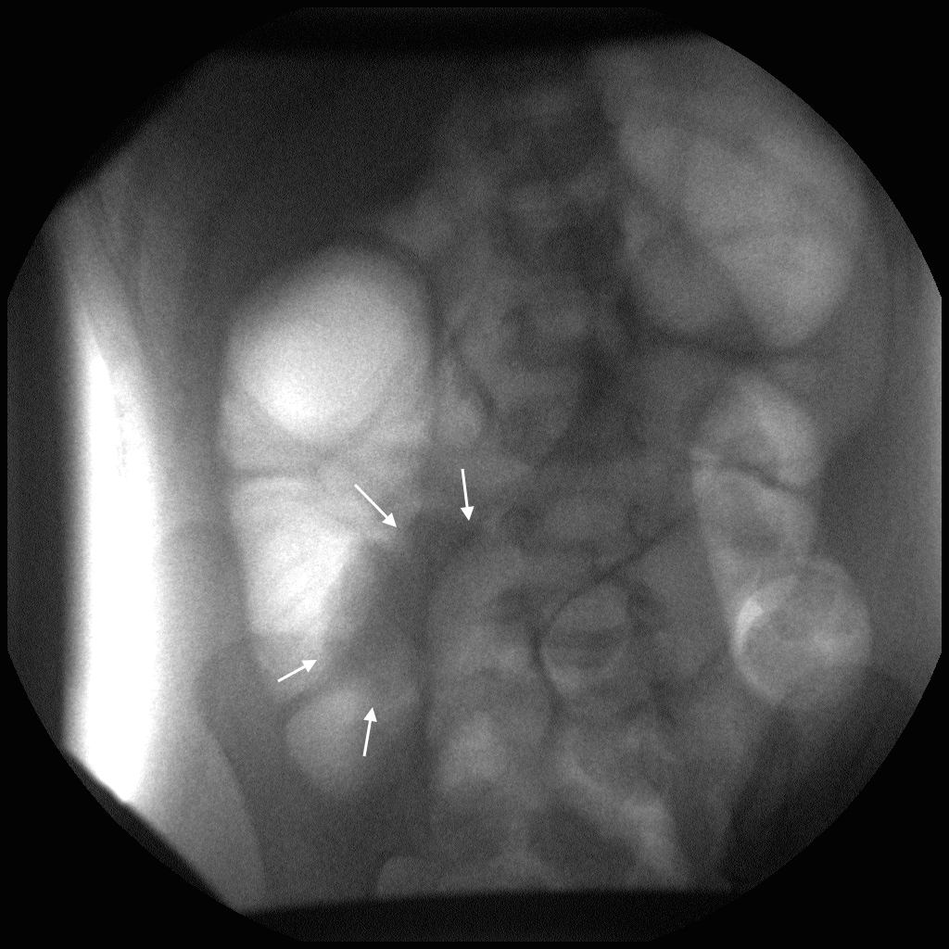

Charlotte – image 14.

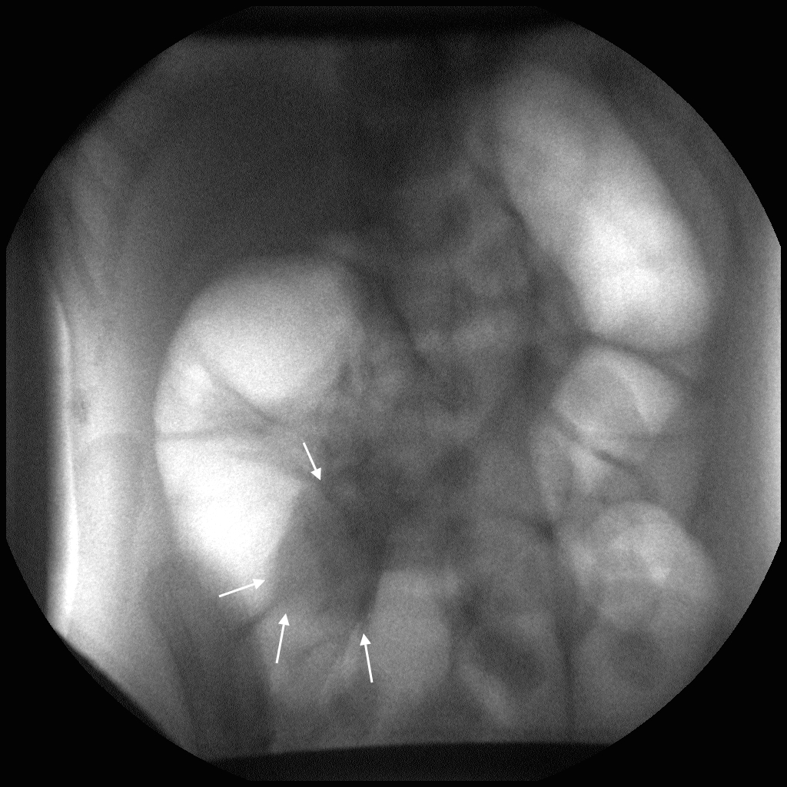

Charlotte – image 15.

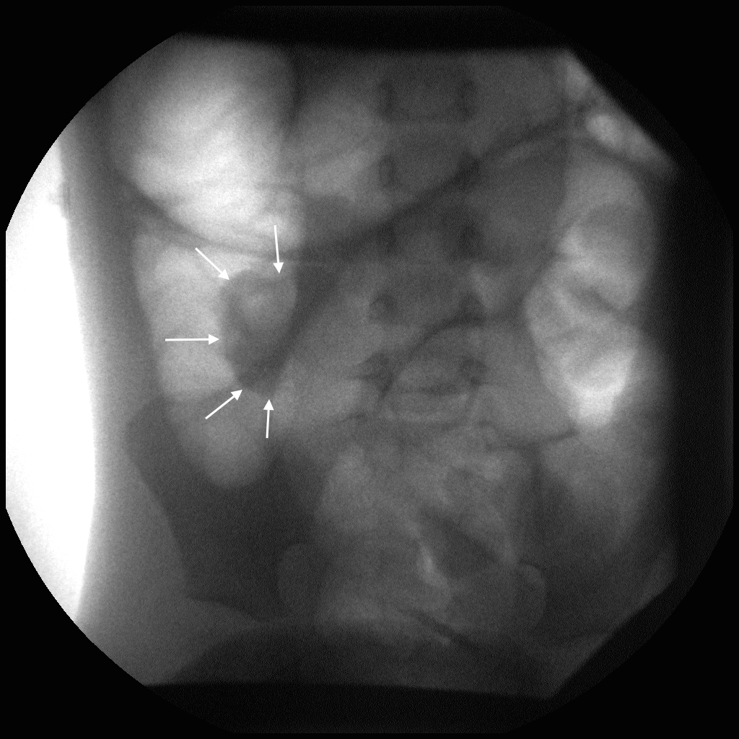

Charlotte – image 16.

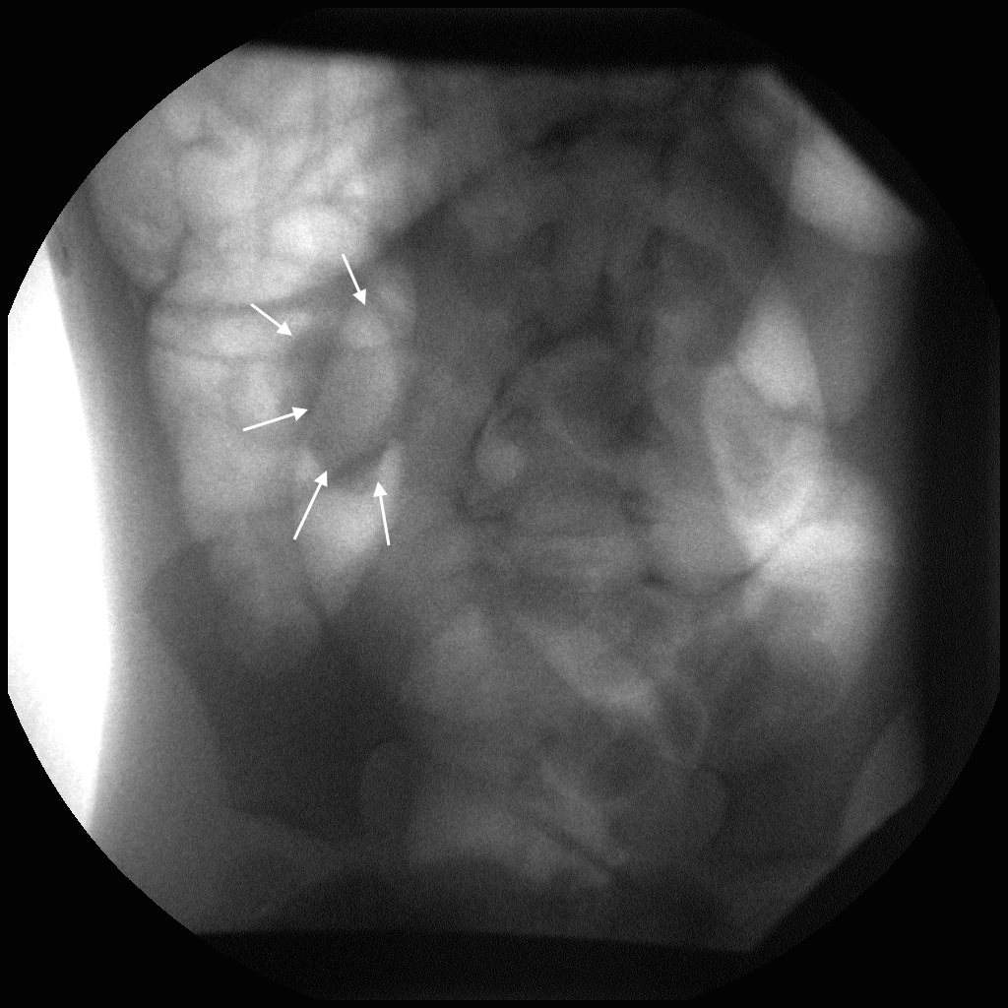

Charlotte – image 17.

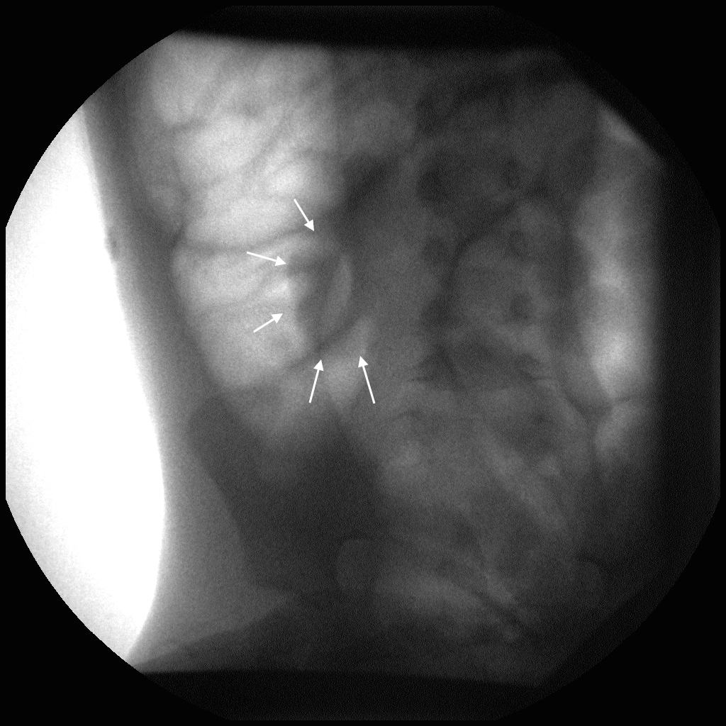

Charlotte – image 18.

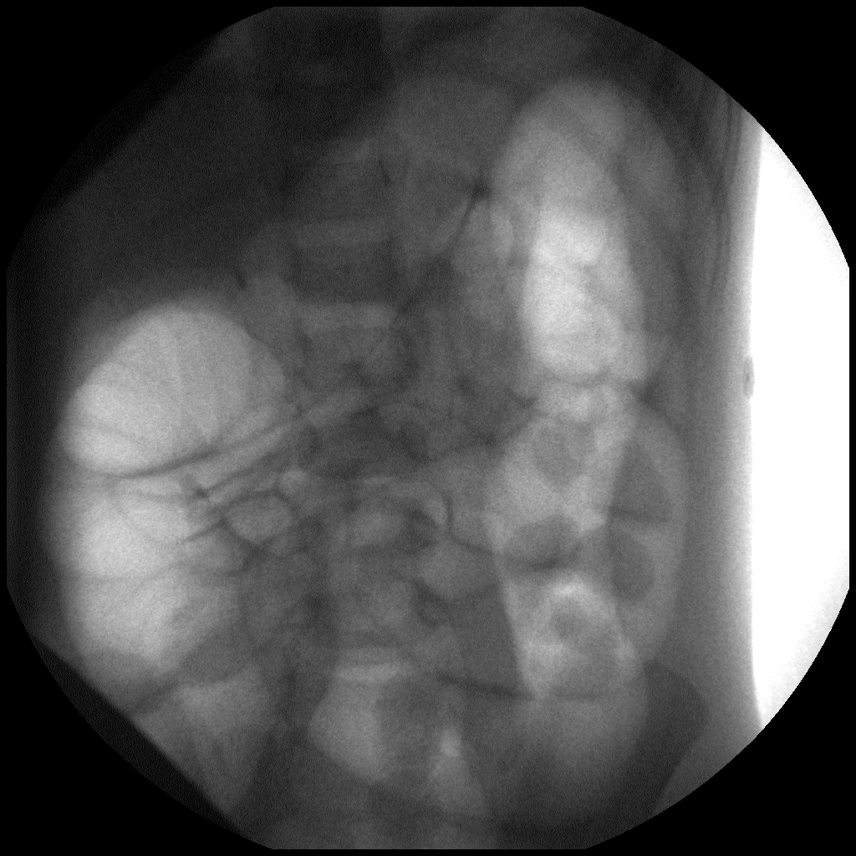

Charlotte – image 19. Notice the loops of air-filled small bowel in the midabdomen, indicative of successful reduction, and the soft tissue mass is no longer evident.

1. David: 12 m/o boy with poor PO intake, non-bilious vomiting, and crampy abdominal pain. He has recently been treated for an ear infection and sent home on Amoxicillin. Temperature 98.6, Pulse 100. He is impossible to examine as he screams every time a doctor comes near him.   
   *Instructor’s Notes:* This is another patient with a reducible intussusception.

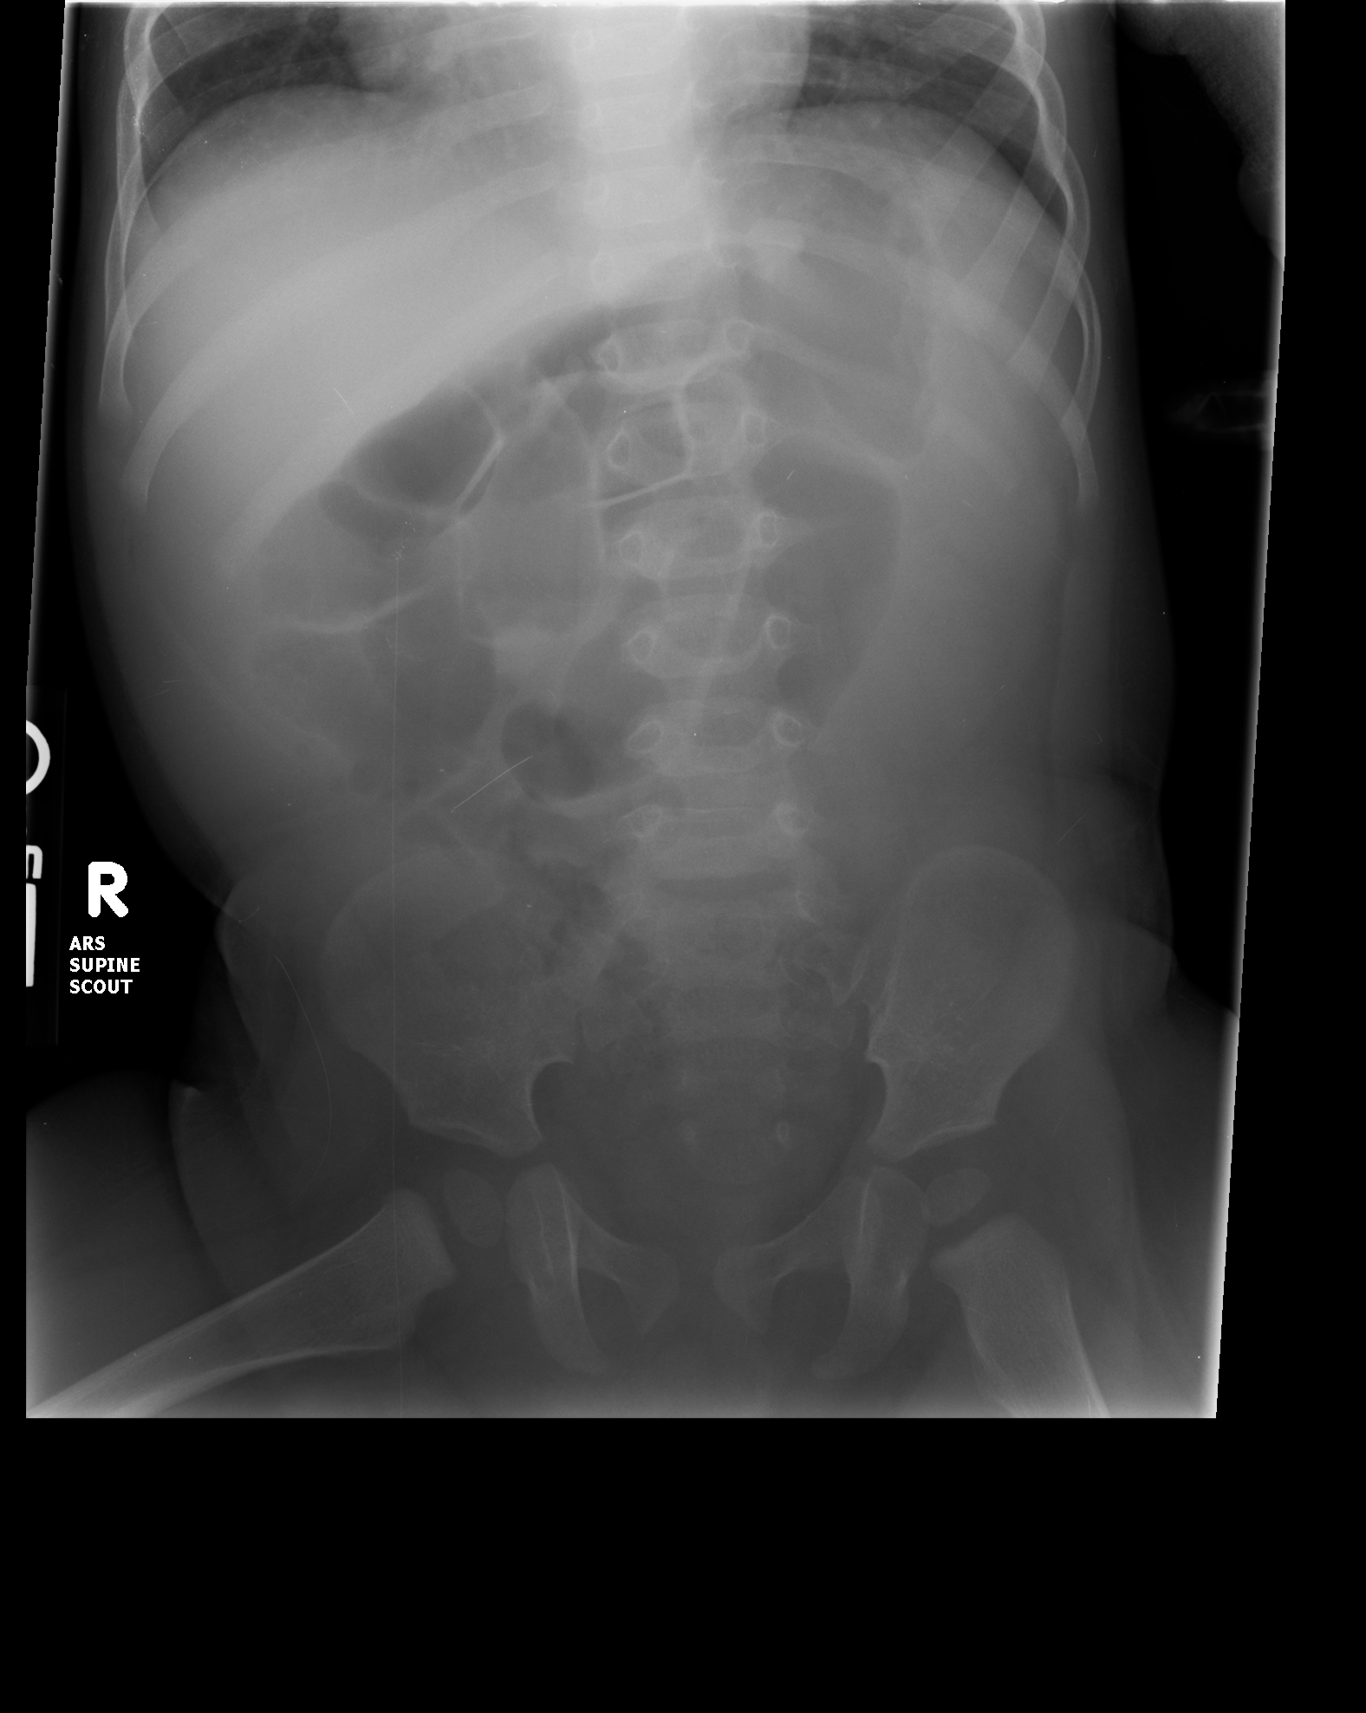

**Figure 9.** David – initial radiograph. Note the absence of gas in the left colon and soft tissue fullness in the right lower quadrant.

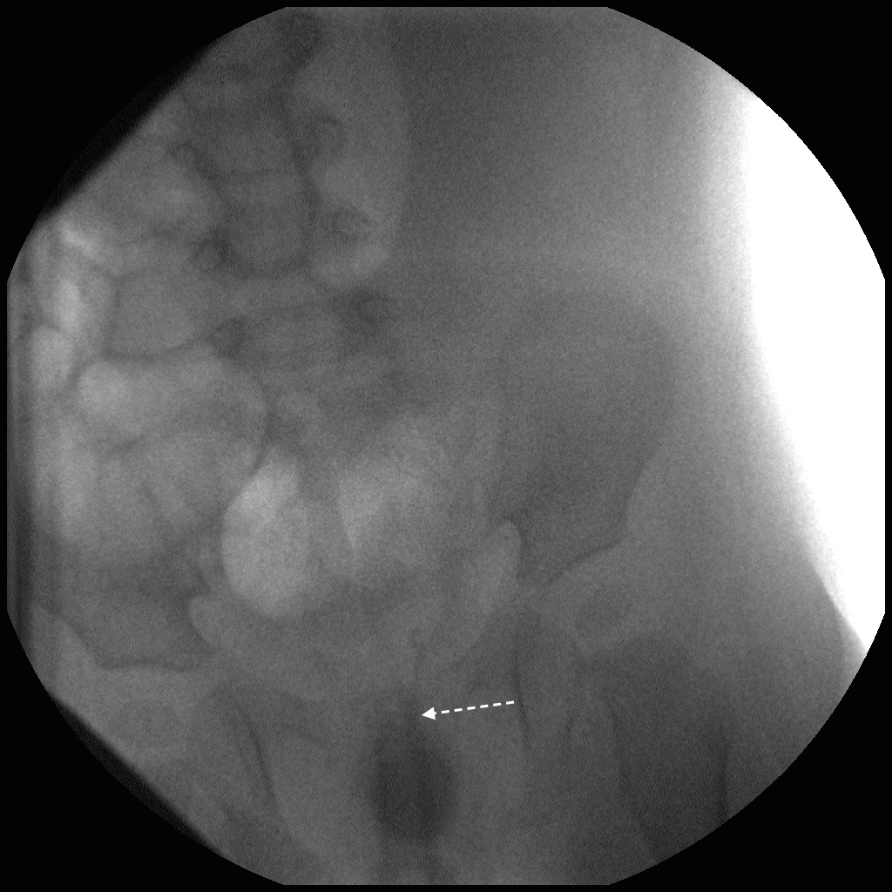

David – image 1. The dashed arrow demonstrates the rectal tube in place.

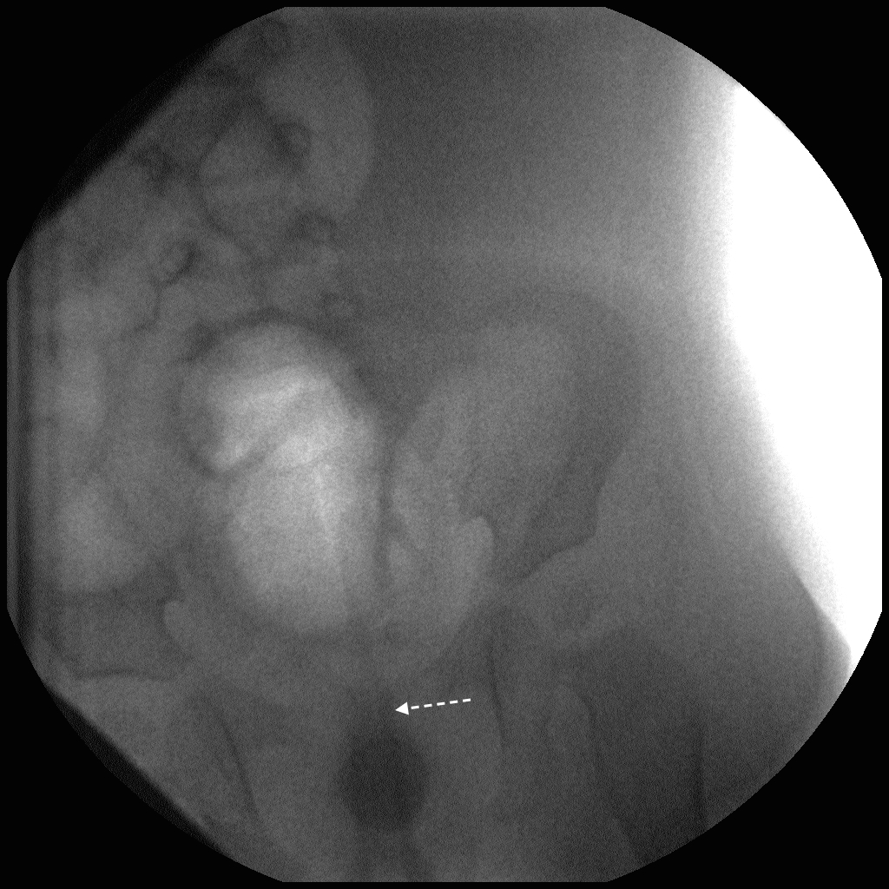

David – image 2. The dashed arrow indicates the rectal tube. Gas has begun to distend the sigmoid colon.

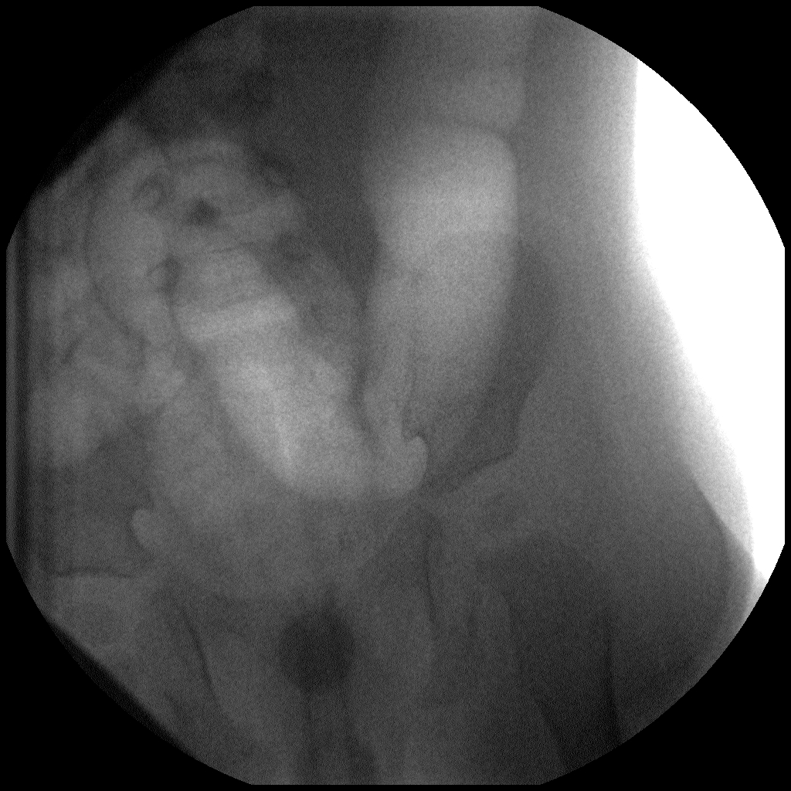

David – image 3. Gas fills the sigmoid colon and extends into the descending colon. The intussusceptum is not yet seen.

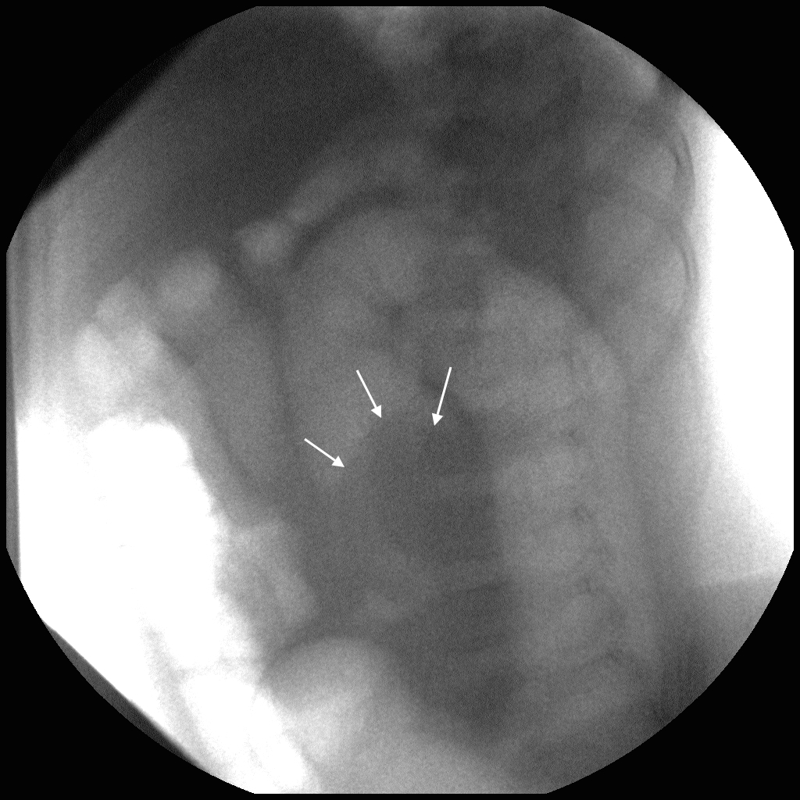

David – image 4. Solid arrows outline the intussusceptum on this and subsequent images.

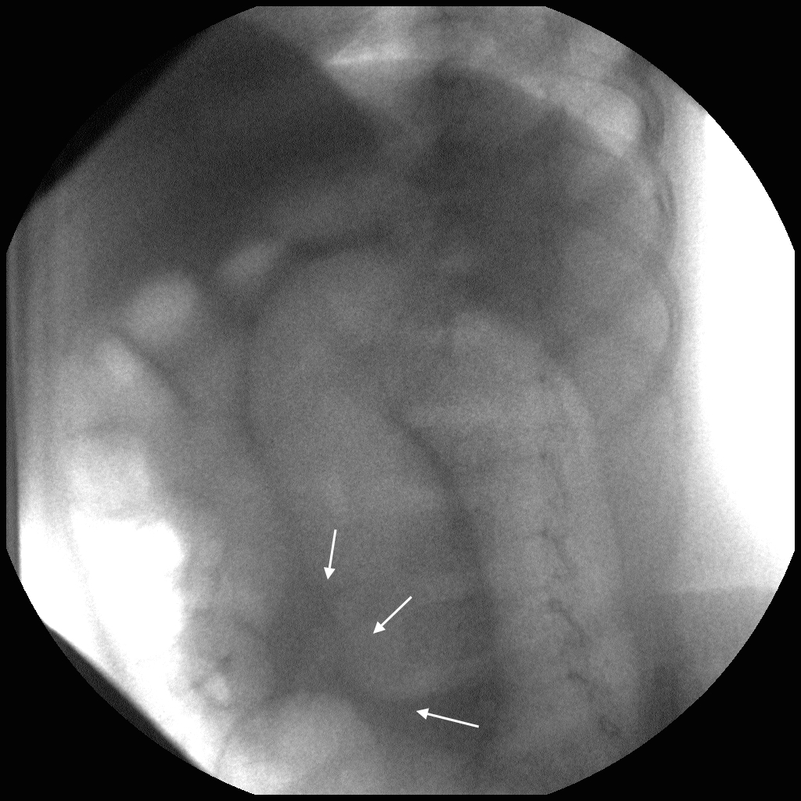

David – image 5. The intussusceptum is admittedly subtle on this image.

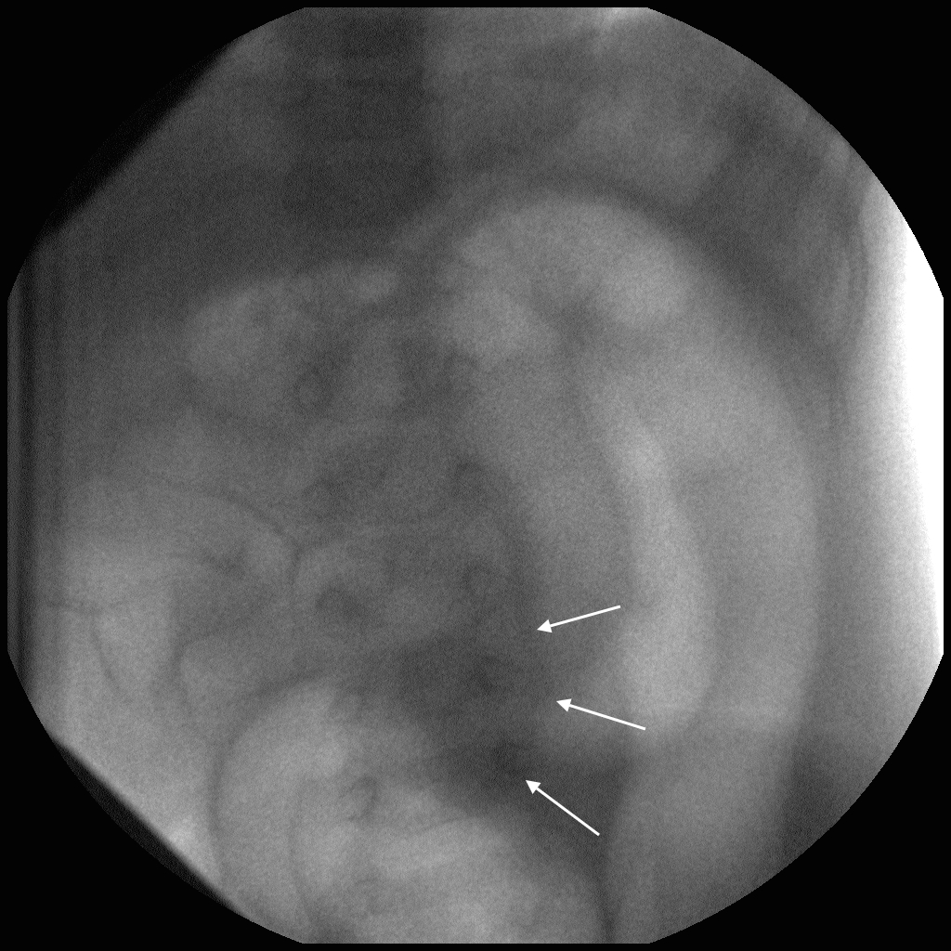

David – image 6.

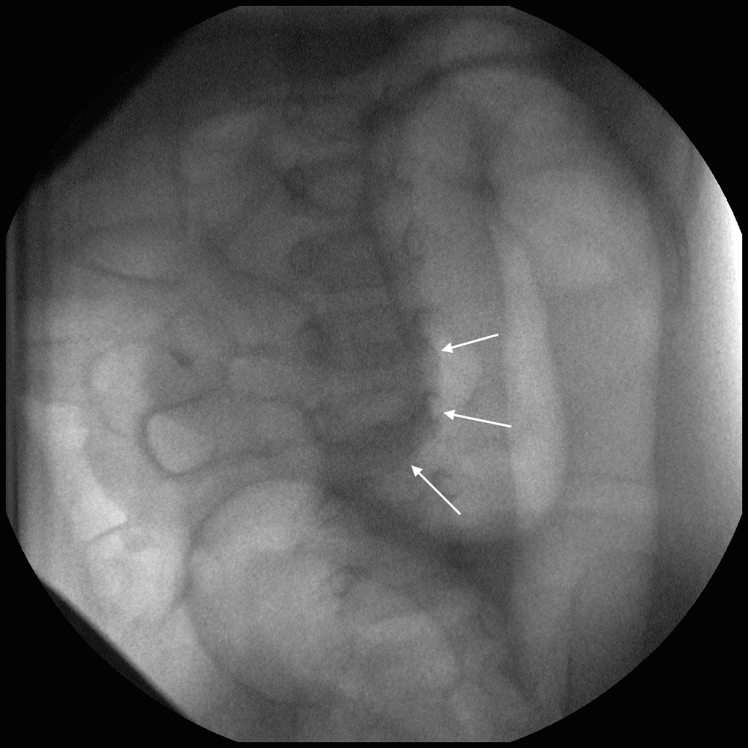

David – image 7.

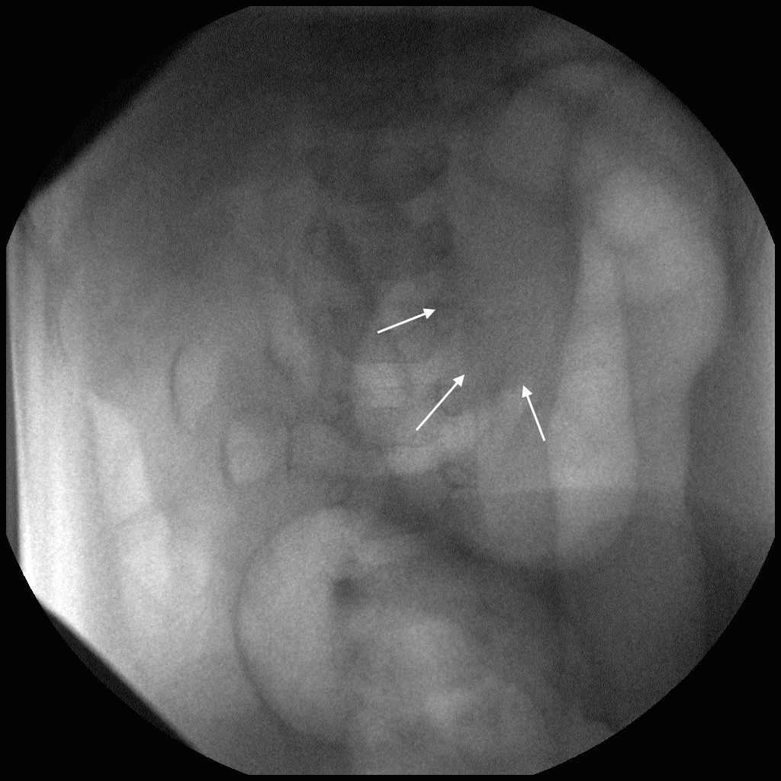

David – image 8.

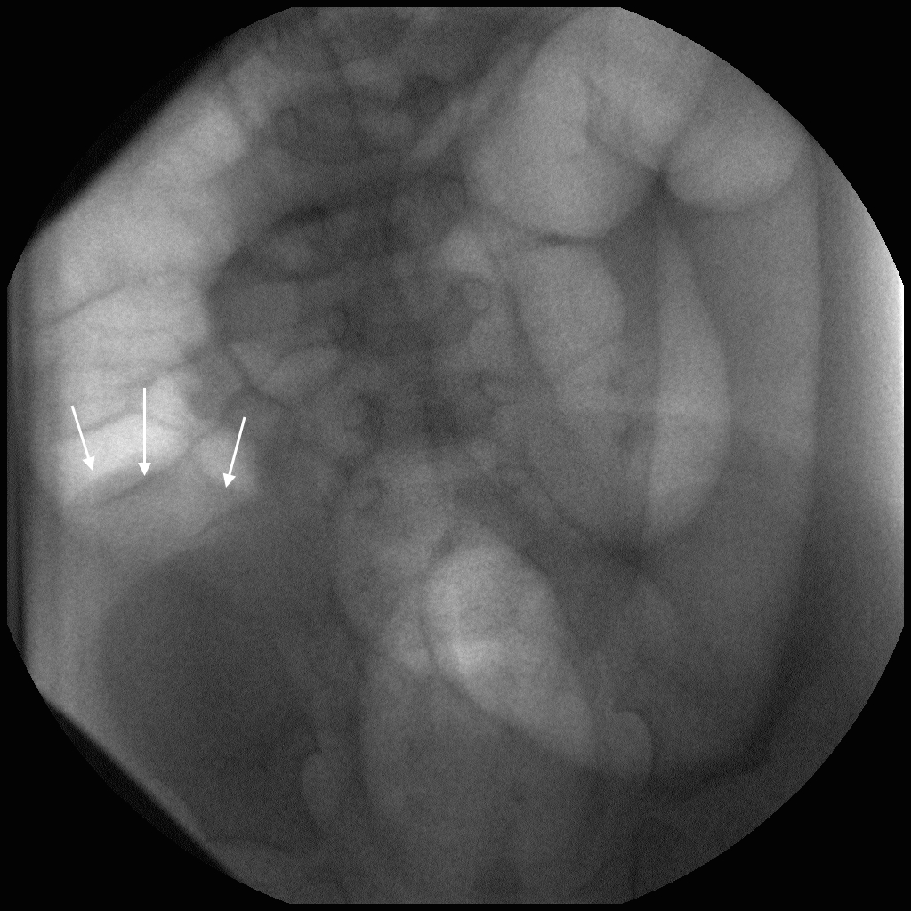

David – image 9. The intussusceptum has reduced significantly since the prior image.

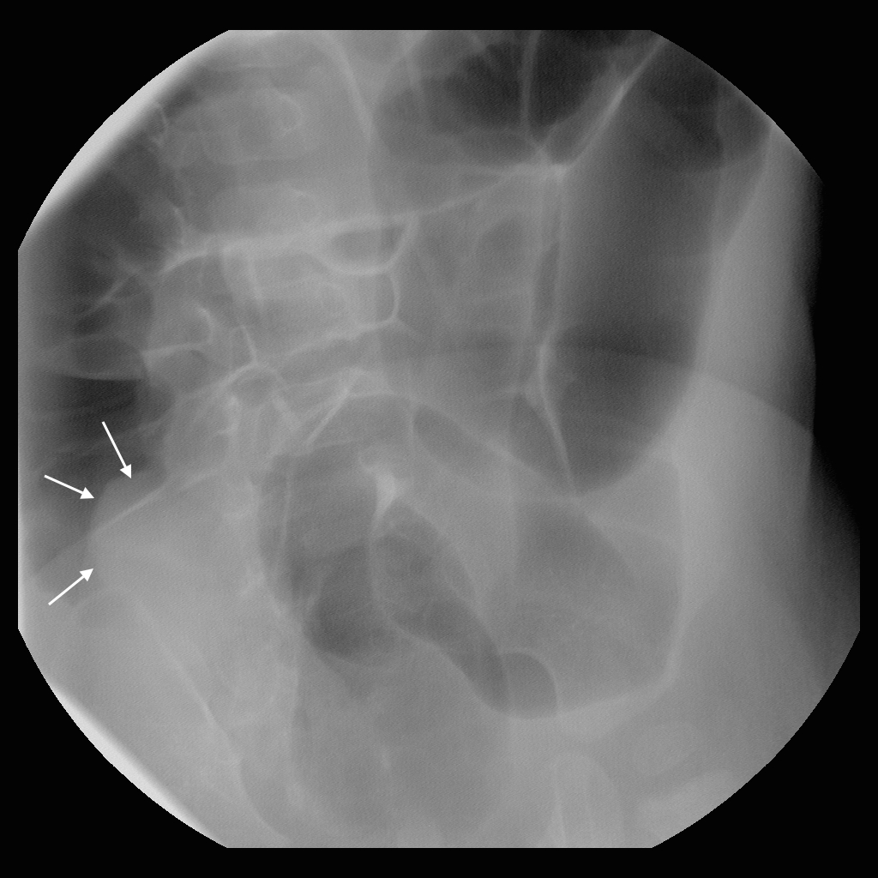

David – image 10.

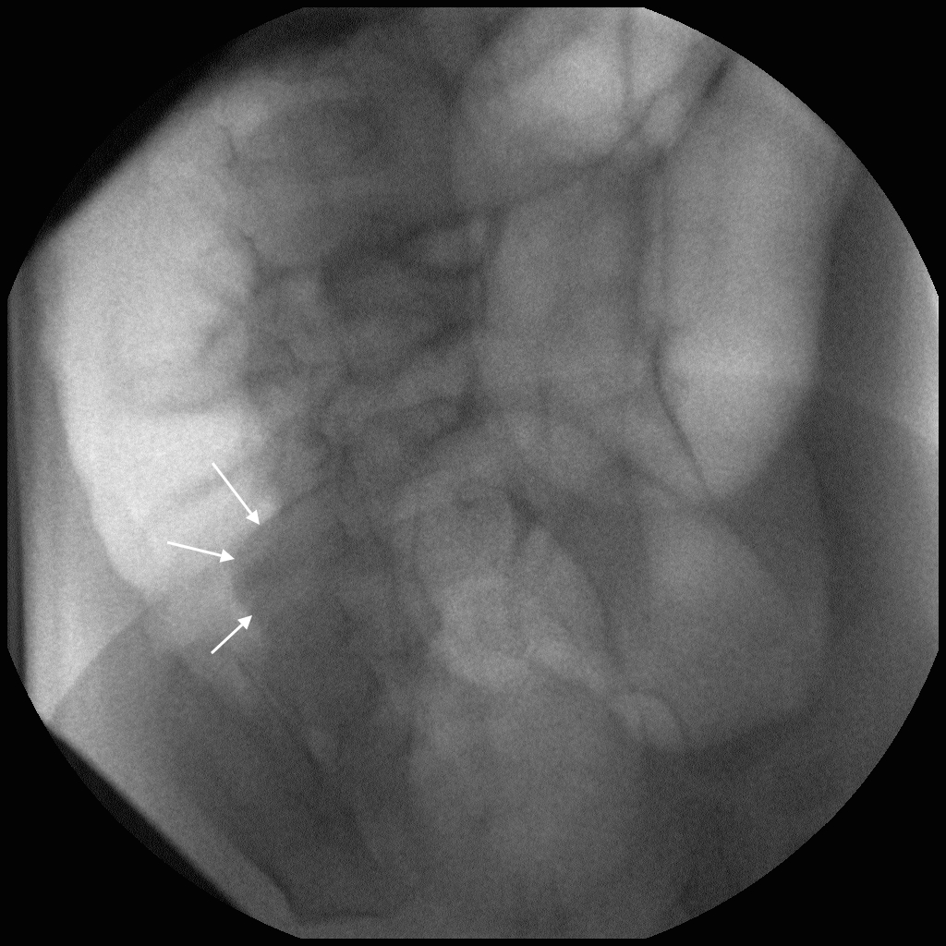

David – image 11. The intussusceptum is near the iliocecal valve.

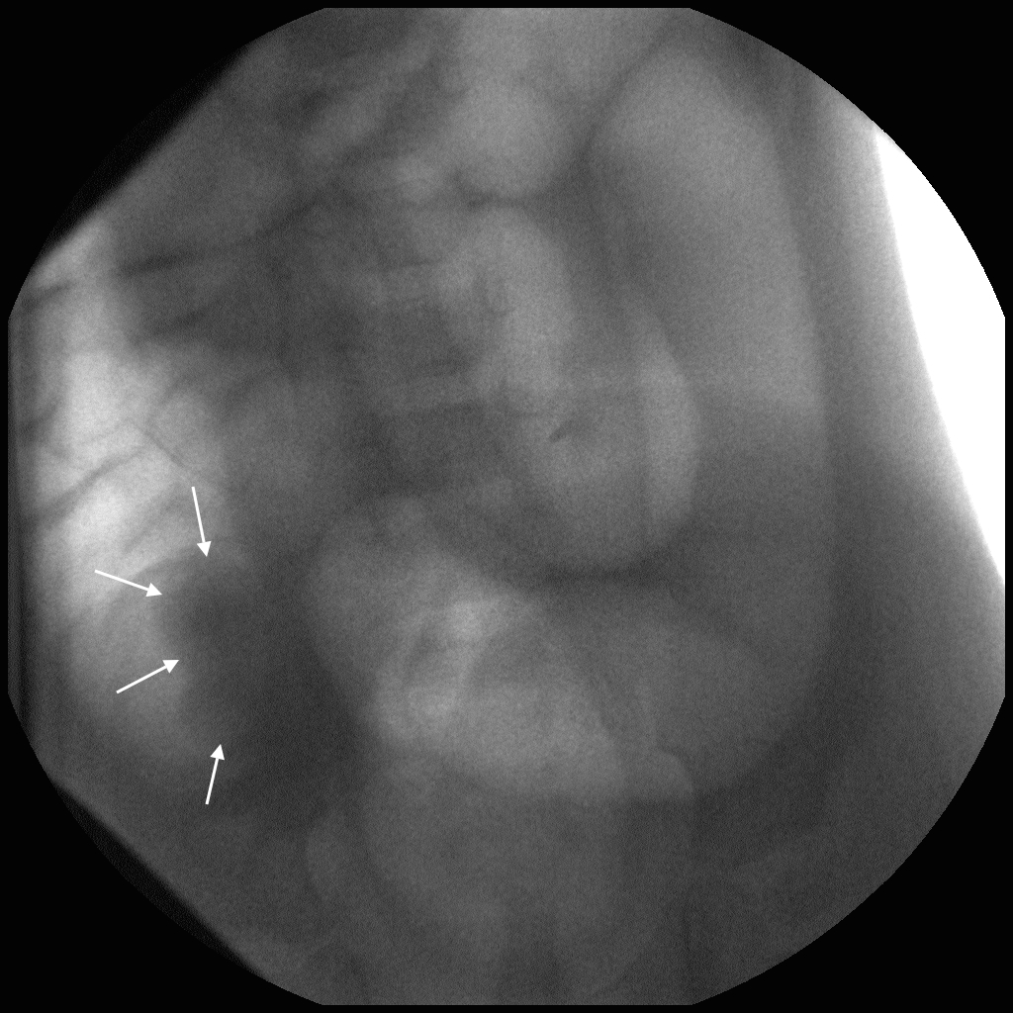

David – image 12.

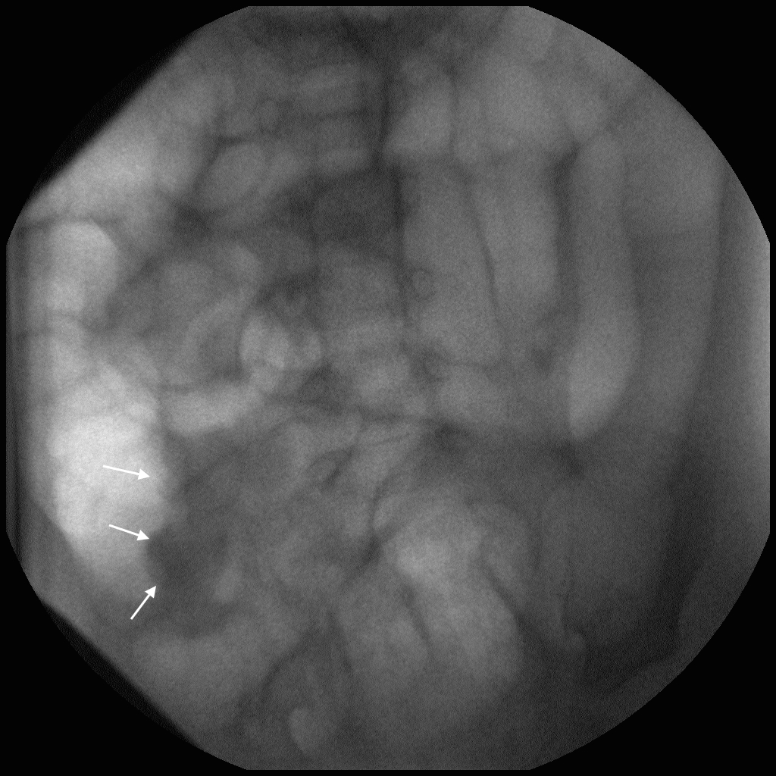

David – image 13.

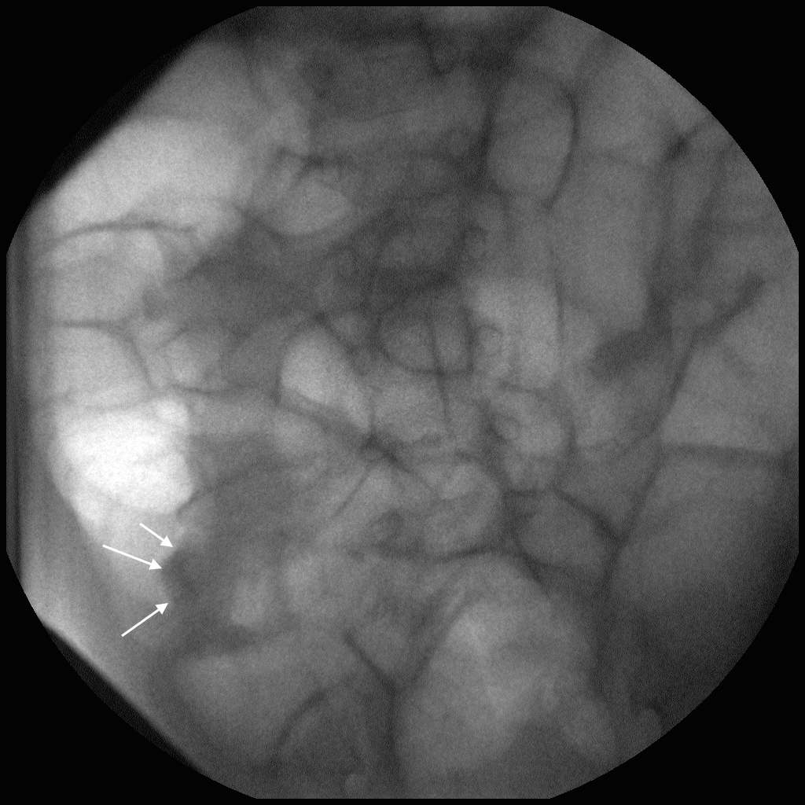

David – image 14.

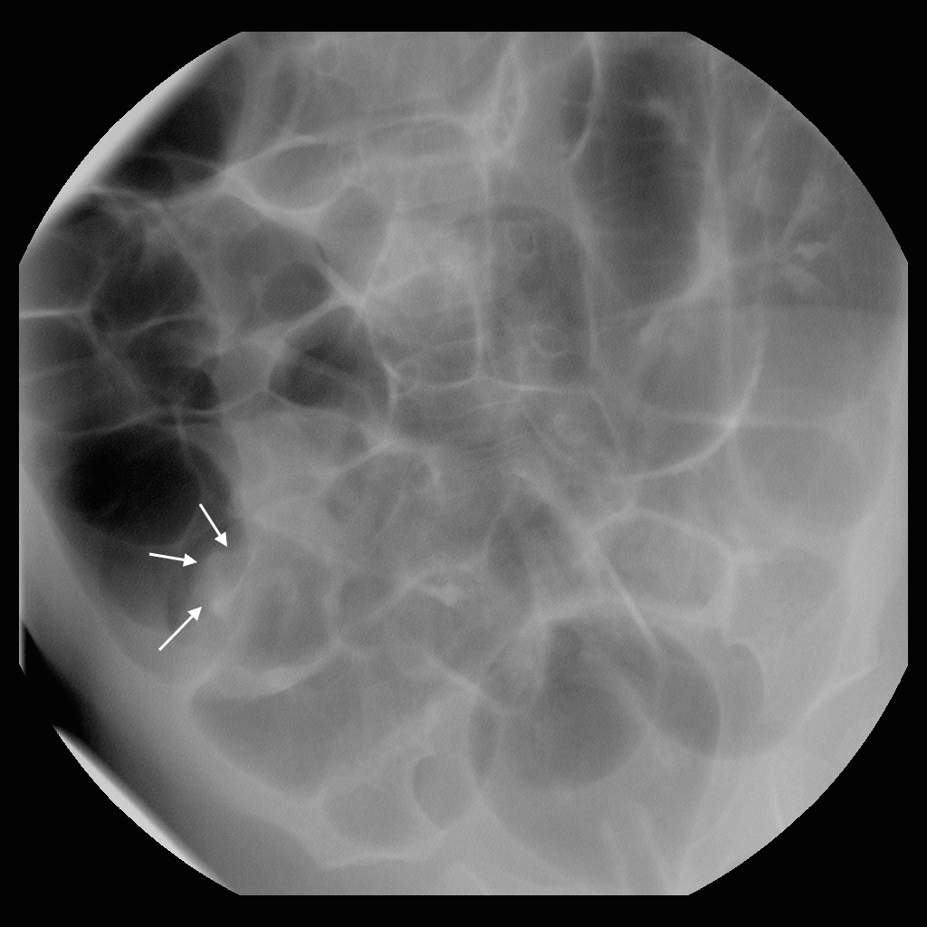

David – image 15.

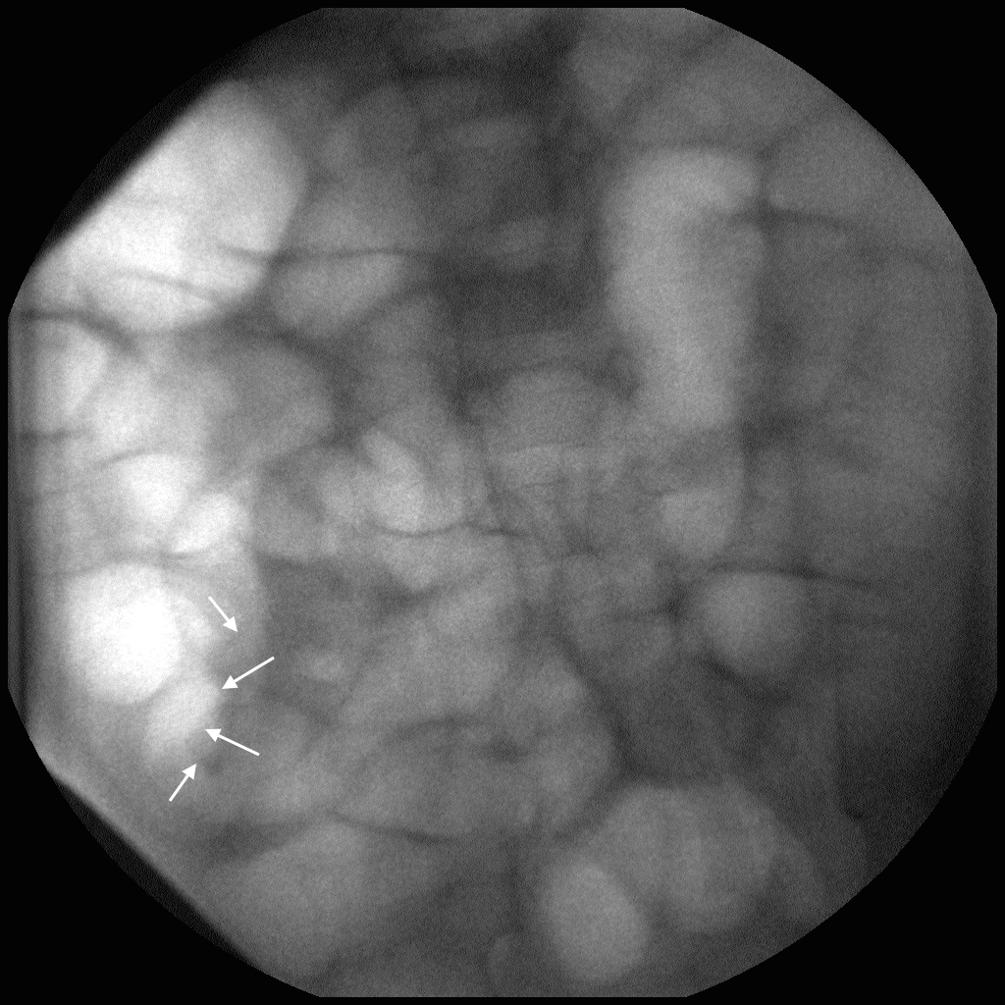

David – image 16. The intussusceptum is small, but definitely protrudes from the iliocecal valve. There is gas extending into the small bowel.

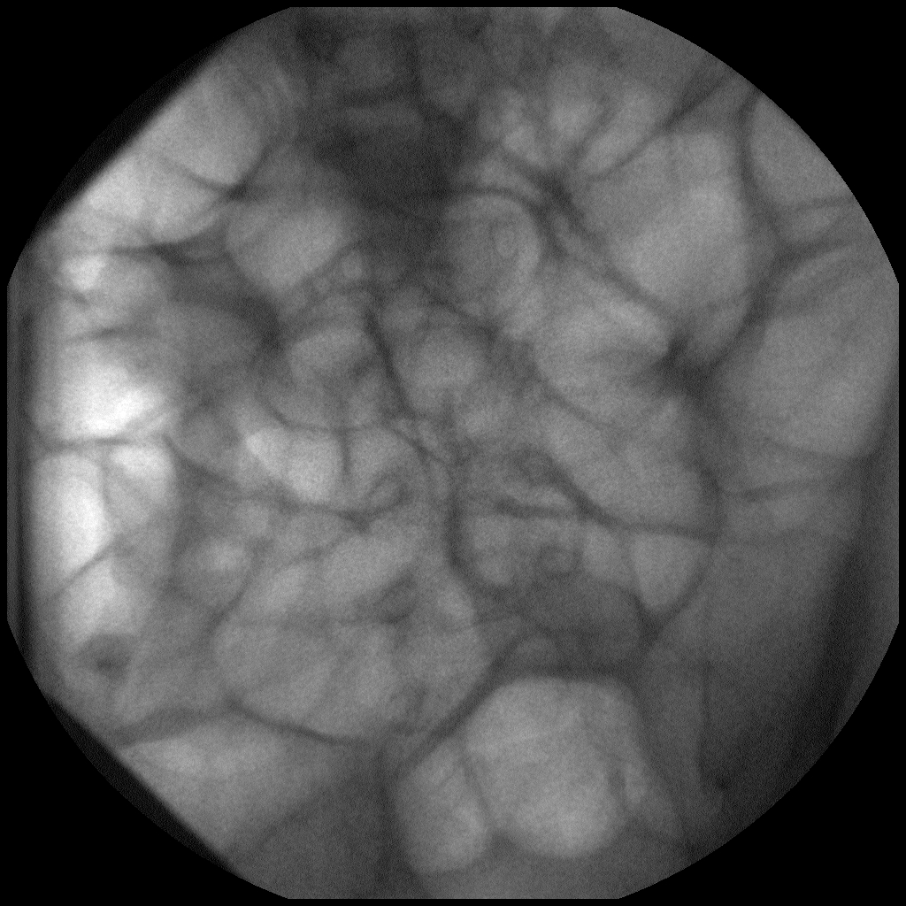

David – image 17. The intussusceptum has finally reduced.

1. Emily: 2 y/o girl, previously healthy, who is s/p reduction of intussusception 2 days earlier and was discharged from the hospital last night. For 24 hours before discharge, she had no abdominal pain and was eating normally. Today she has been very quiet and complained of intermittent abdominal pain. She passed 1 stool with a few flecks of blood but no current jelly stool. No vomiting, but decreased appetite. Temperature 98.6, Pulse 90. Abdominal exam was soft with minimal tenderness but no peritoneal signs.   
   *Instructor’s Notes:* The ultrasound image demonstrates a typical ilio-ileal intussusception, which as a transient phenomenon does not require reduction. However, this was not recognized, and an enema was performed anyway. The “reduction” should progress very quickly, with air rapidly reaching the small bowel. This provides an opportunity for the instructor to talk about how not all intussusceptions will be symptomatic or significant. Transient small bowel intussusceptions are of unclear but doubtful clinical significance.

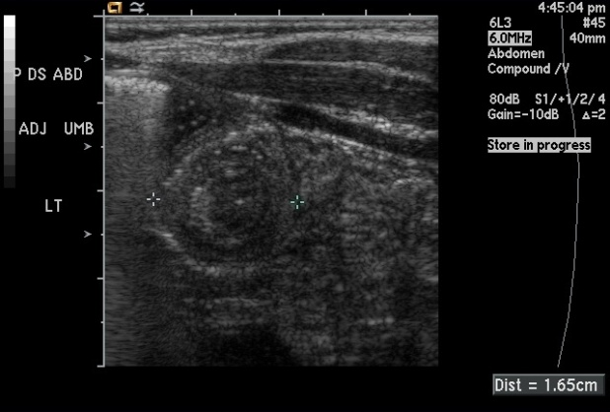

**Figure 10:** ultrasound image of Emily’s transient small bowel intussusception (note the size of only 1.7 cm).

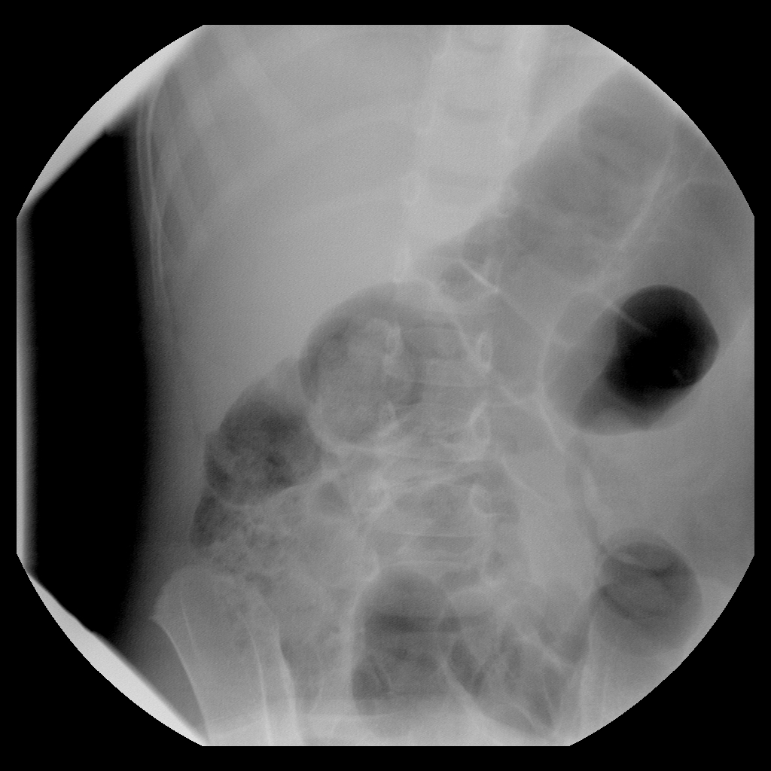

**Figure 11:** Emily – initial radiograph. Note the gas and stool in the expected location of the cecum.

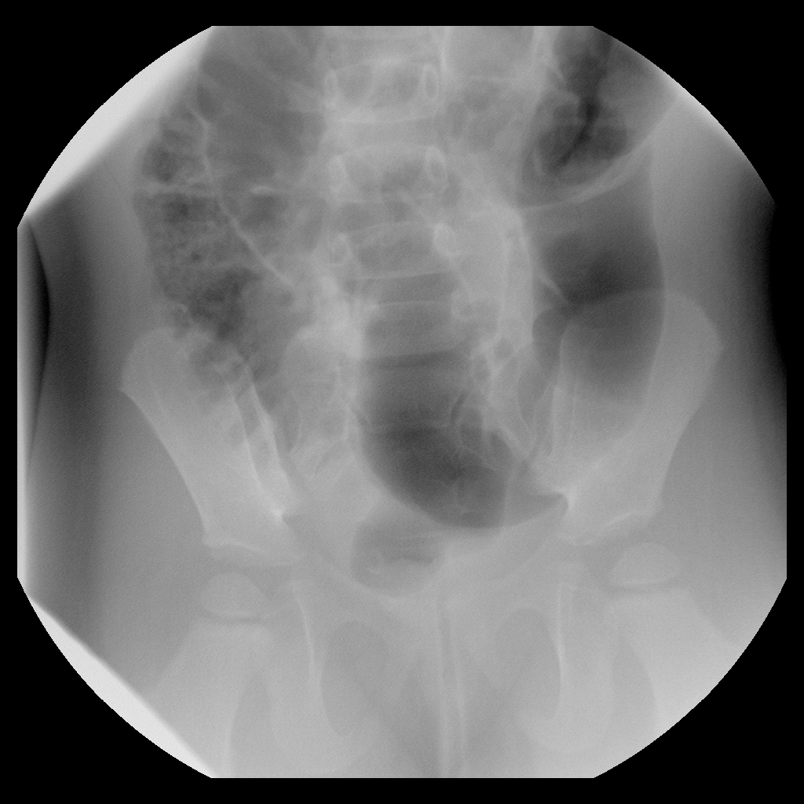

Emily – image 1. Gas extends throughout the colon.

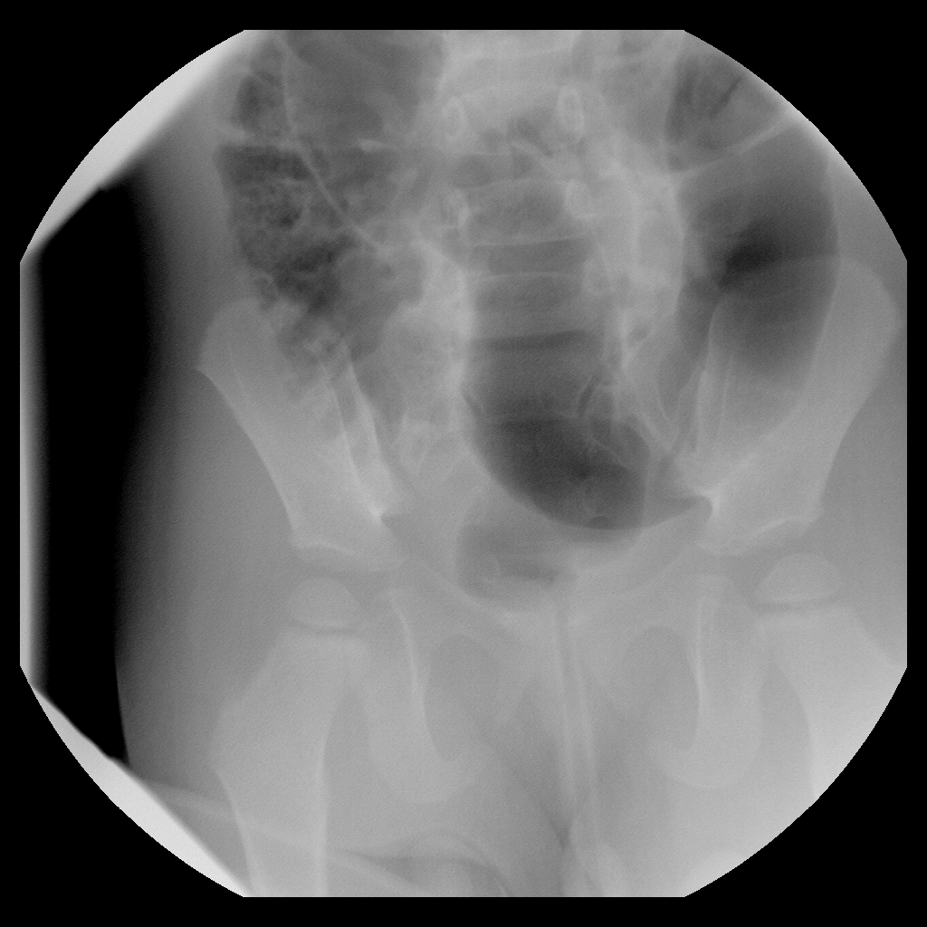

Emily – image 2.

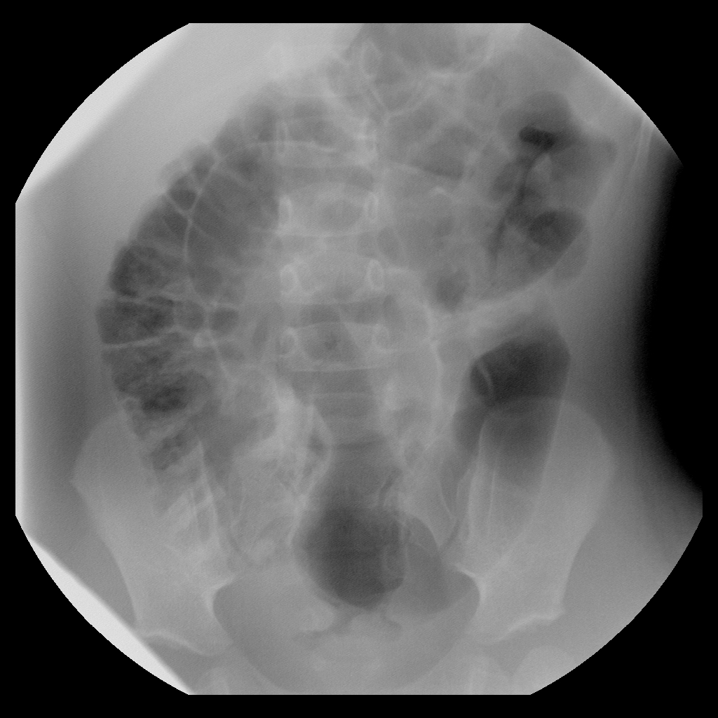Emily – image 3. Again, gas extends throughout the colon.

1. Francisco: 14 m/o boy with abdominal pain and bloody, mucousy stool since this morning. The parents say he was normal last night and slept until this morning when they noticed blood in his diaper and intermittent abdominal pain. He seems slightly irritable and did not want to eat breakfast. He was brought directly to the ED. Temperature 99.2, Pulse 100. Abdominal exam is soft, nontender, mildly distended.   
   *Instructor’s Notes*: This intussusception is very easy to reduce.

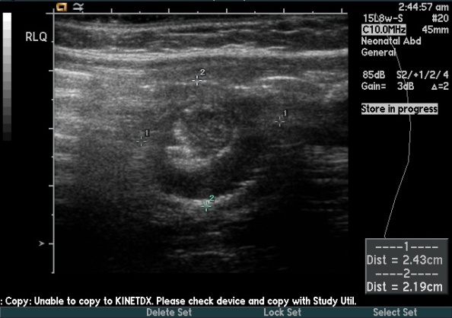

**Figure 12:** ultrasound image of Francisco. Note the large size and the “pseudokidney” appearance.

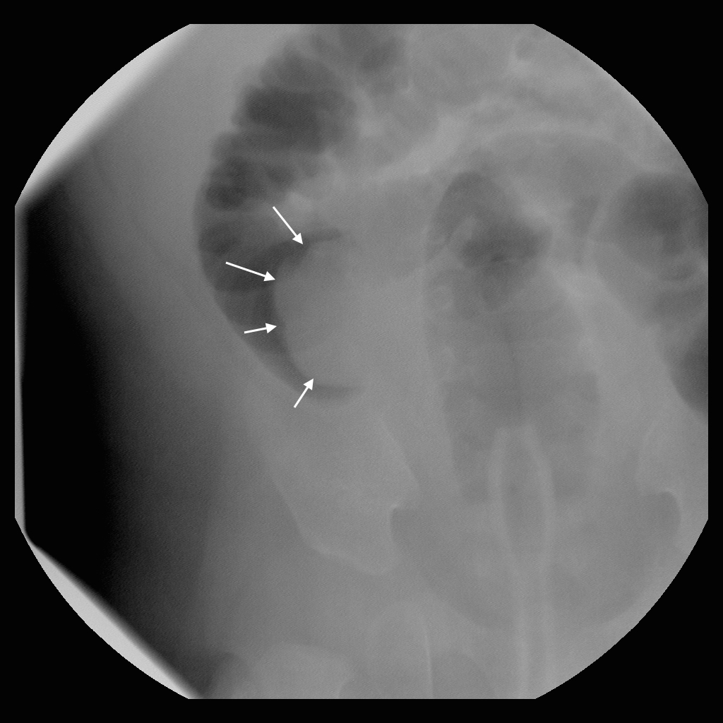

Francisco – image 1. The solid arrows outline the intussusceptum on this and subsequent images.

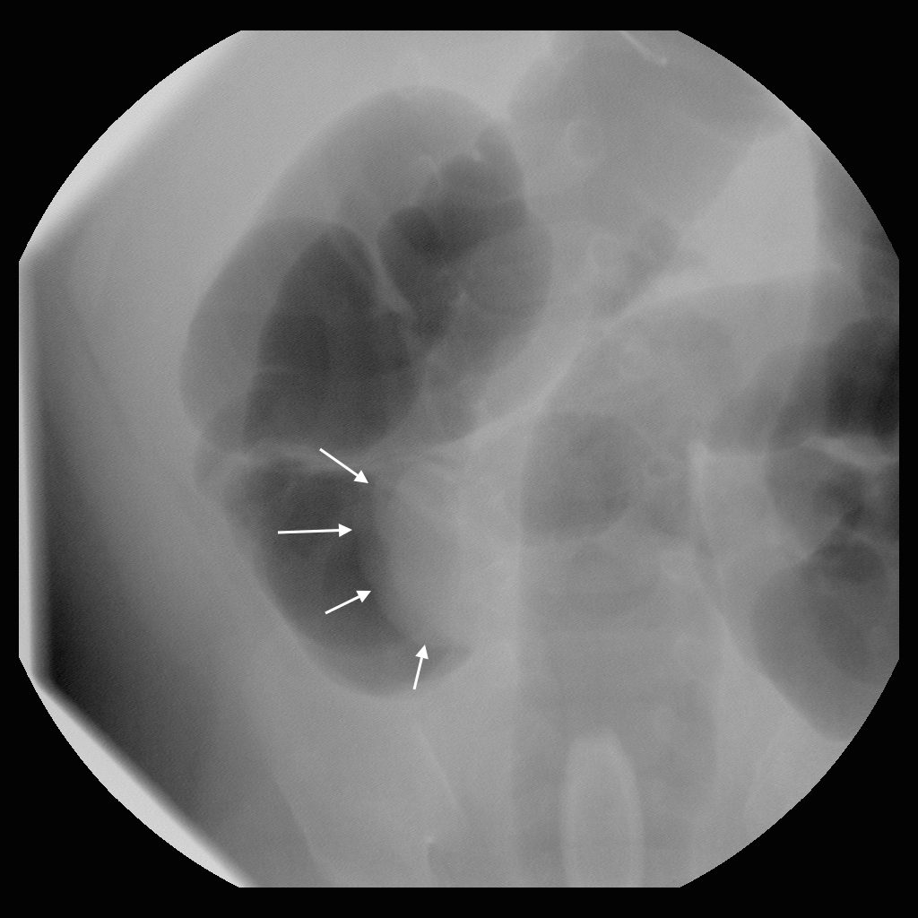

Francisco – image 2.

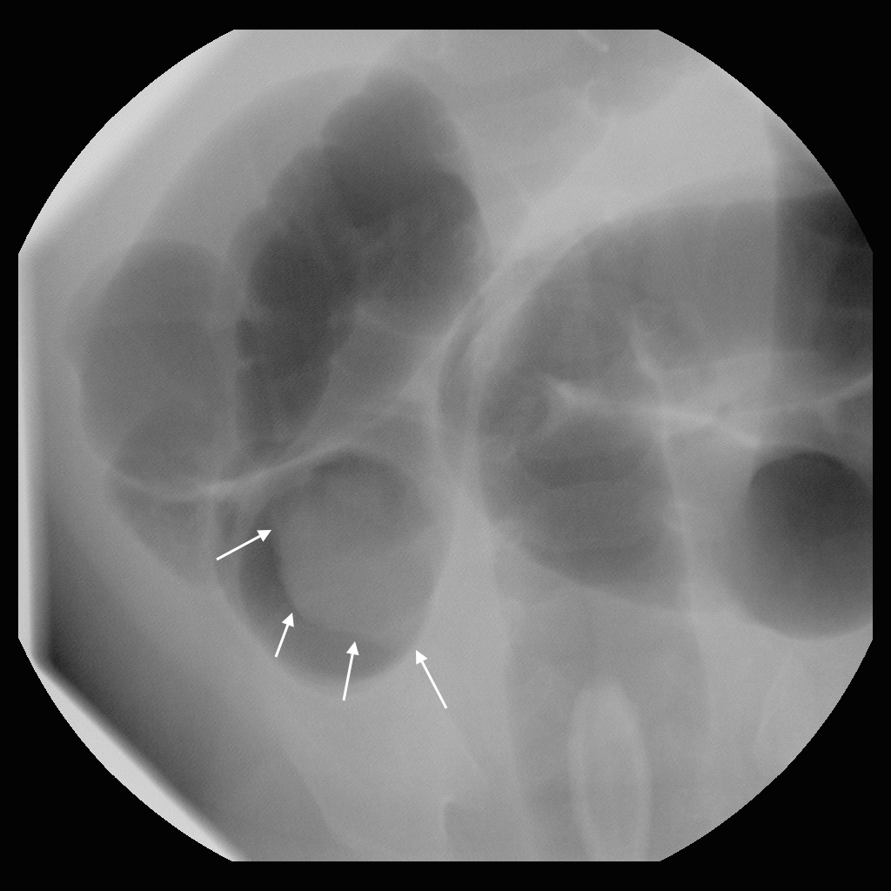

Francisco – image 3.

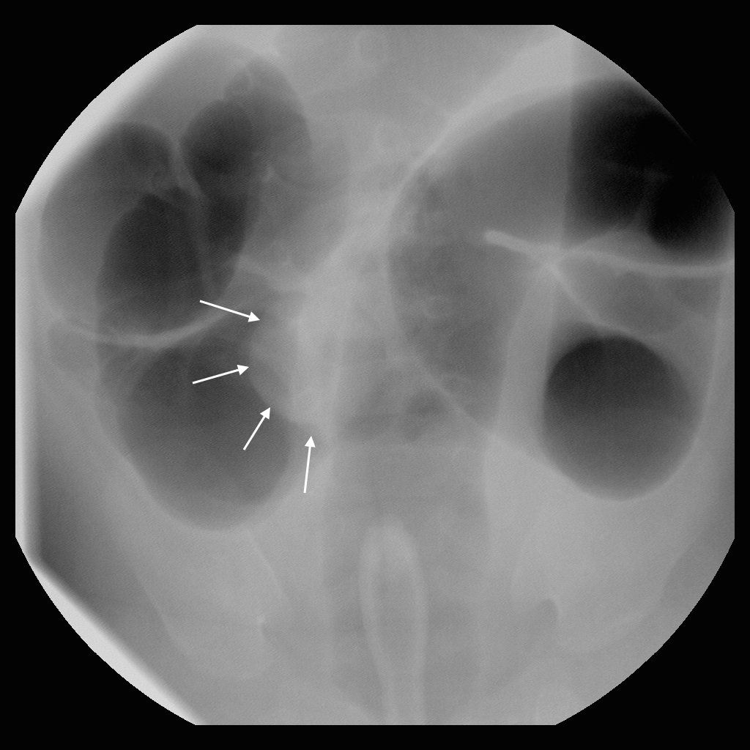

Francisco – image 4.

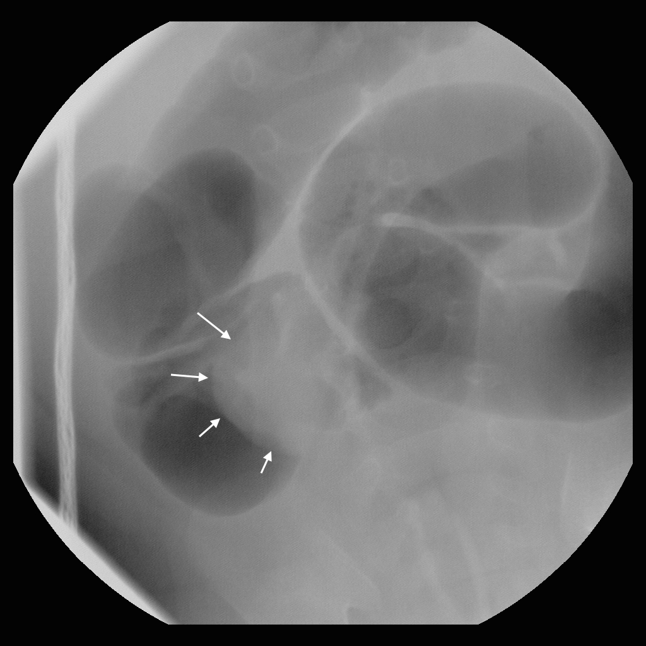

Francisco – image 5.

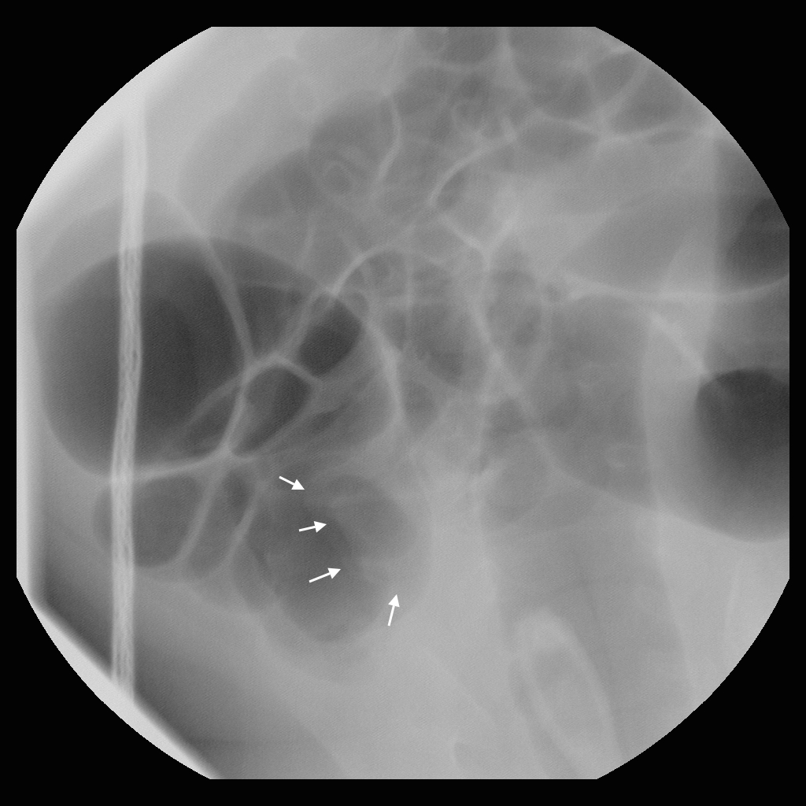

Francisco – image 6.

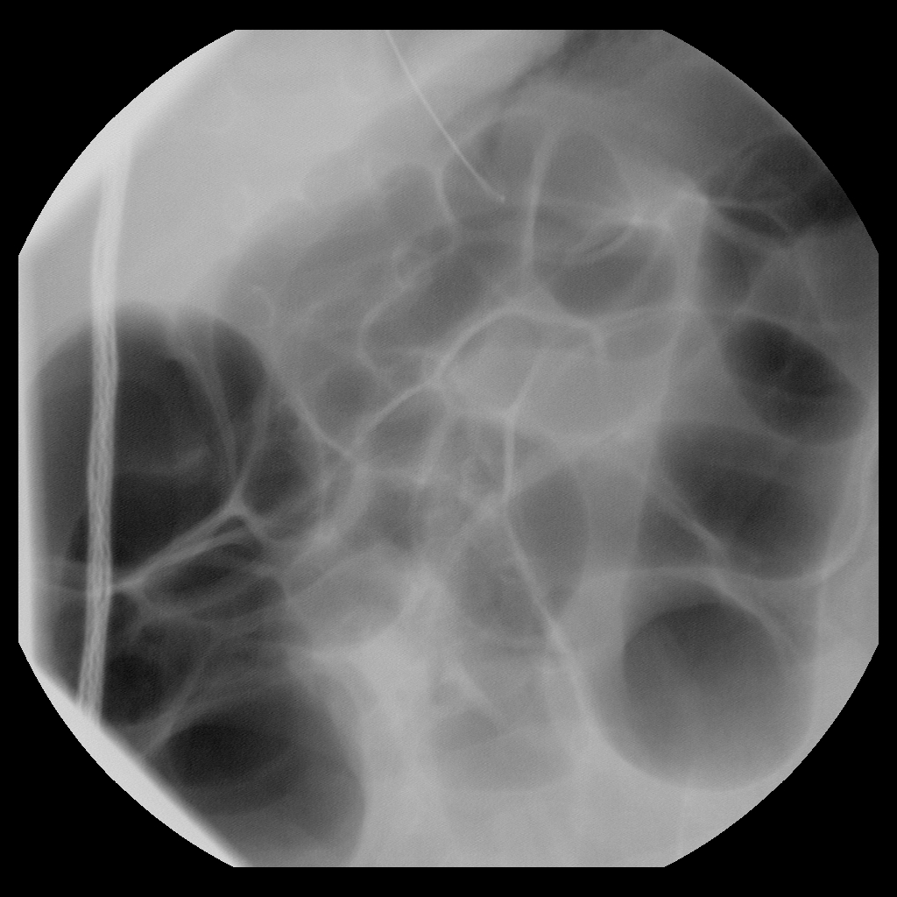

Francisco – image 7. The intussusceptum is not seen on this or the subsequent images, but they show progressive distention of small bowel with gas, indicating successful reduction.

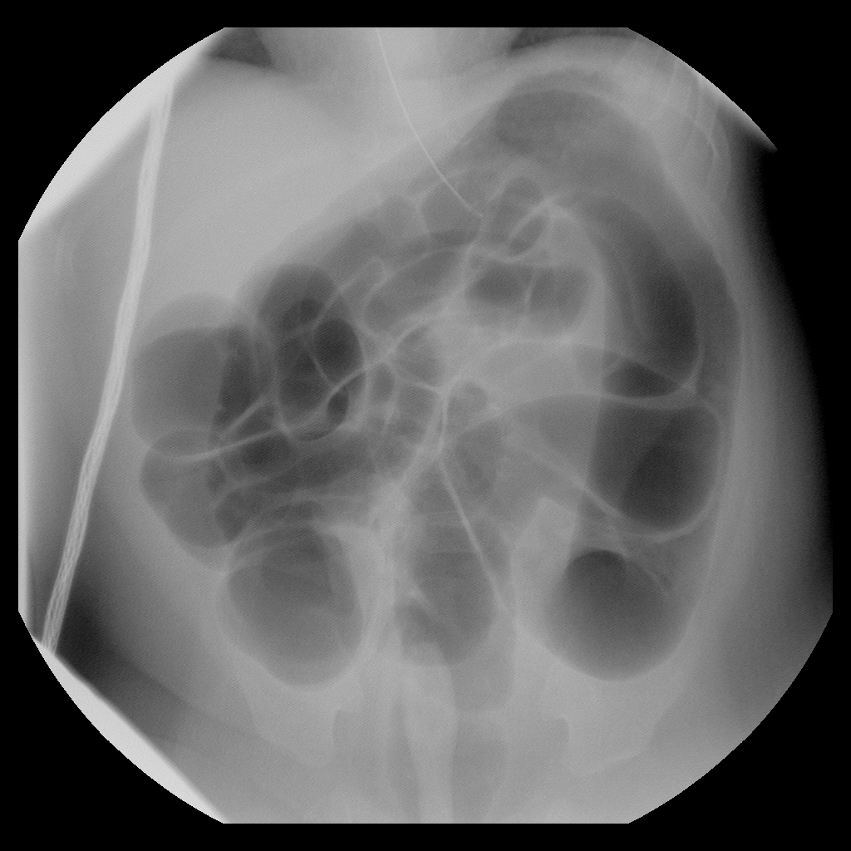

Francisco – image 8.

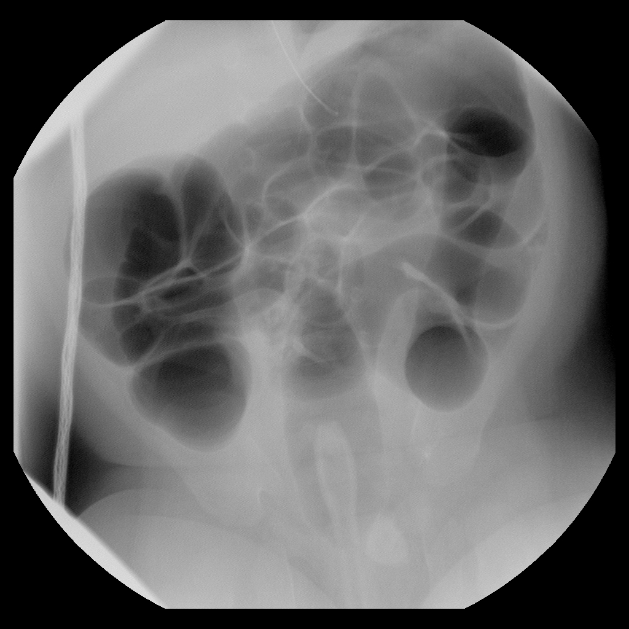

Francisco – image 9.

1. Gary: 2 year old boy presents with two days of mild diffuse abdominal pain with occasional bloody stools. He became acutely worse and was rushed to the ER.   
   *Instructor’s Notes:* This is a patient who has intraperitoneal free air on the preprocedure radiograph. The student should recognize this and immediately send for the surgeon. See Figure 14 for the patient’s classic “football sign.”

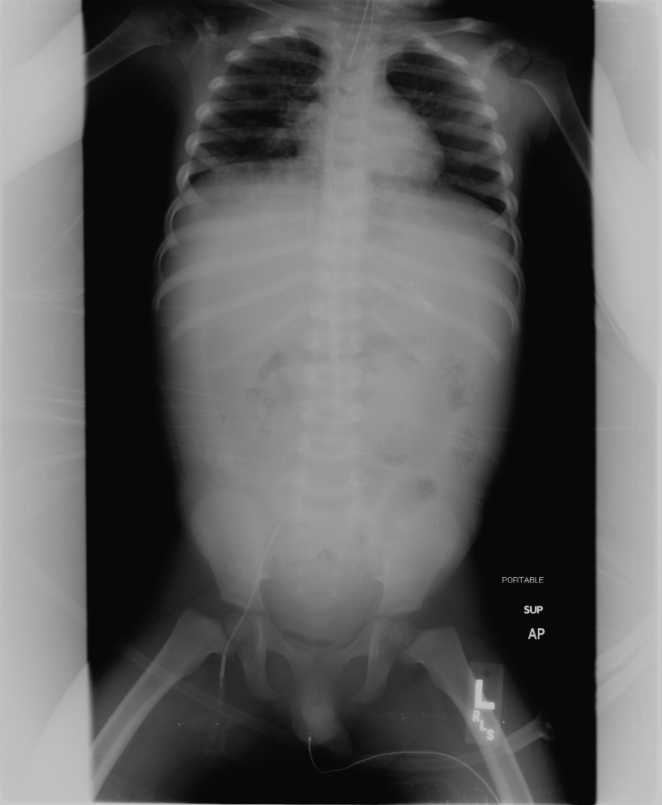

**Figure 13:** The classic “football sign” with air outlining the falciform ligament and filling the abdomen. Note that the radiograph should always get whiter, indicating an increase in density, when moving from lateral to medial over the liver, and that this radiograph violates this rule.

Perforation can occur in any procedure, but would be extraordinarily unlikely in situation #5.

Acknowledgement: Many thanks to Lisa Abramson, pediatric surgeon.

Pre-procedural checklist: We include a pre-procedural checklist, as follows. We realize that practices vary; the checklist is intended to prompt discussion of important considerations. The instructor and/or resident can refer to the overview of intussusception section of this manual for additional information about the pros and cons of different approaches.

1. Pediatric surgery has been consulted and is aware of the patient.

2. Abdominal radiographs (AP and Cross-table lateral or decubitus) demonstrate no free air.

3. No peritoneal signs are present.

4. Patient is hemodynamically stable.

5. IV access has been secured.

6. Parents or guardians have consented to the procedure (preferable).

7. Large-bore angiocath available at bedside.

8. Provider in the room who will be primarily responsible for the patient (nurse or doctor).

9. Patient's vital signs are being monitored.

10. What catheter will be used?

11. Will you sedate the patient?

## References

1. Bisset, G.S., 3rd and D.R. Kirks, *Intussusception in infants and children: diagnosis and therapy.* Radiology, 1988. **168**(1): p. 141-5.

2. Navarro, O. and A. Daneman, *Intussusception. Part 3: Diagnosis and management of those with an identifiable or predisposing cause and those that reduce spontaneously.* Pediatr Radiol, 2004. **34**(4): p. 305-12; quiz 369.

3. Ko, H.S., et al., *Current radiological management of intussusception in children.* Eur Radiol, 2007. **17**(9): p. 2411-21.

4. Katz, M., et al., *Gas enema for the reduction of intussusception: relationship between clinical signs and symptoms and outcome.* AJR Am J Roentgenol, 1993. **160**(2): p. 363-6.

5. Stein, M., D.J. Alton, and A. Daneman, *Pneumatic reduction of intussusception: 5-year experience.* Radiology, 1992. **183**(3): p. 681-4.

6. Britton, I. and A.G. Wilkinson, *Ultrasound features of intussusception predicting outcome of air enema.* Pediatr Radiol, 1999. **29**(9): p. 705-10.

7. del-Pozo, G., et al., *Intussusception: trapped peritoneal fluid detected with US--relationship to reducibility and ischemia.* Radiology, 1996. **201**(2): p. 379-83.

8. Lim, H.K., et al., *Assessment of reducibility of ileocolic intussusception in children: usefulness of color Doppler sonography.* Radiology, 1994. **191**(3): p. 781-5.

9. Daneman, A. and O. Navarro, *Intussusception. Part 2: An update on the evolution of management.* Pediatr Radiol, 2004. **34**(2): p. 97-108; quiz 187.

10. Daneman, A., et al., *Perforation during attempted intussusception reduction in children--a comparison of perforation with barium and air.* Pediatr Radiol, 1995. **25**(2): p. 81-8.

11. Kirks, D.R., *Air intussusception reduction: "the winds of change".* Pediatr Radiol, 1995. **25**(2): p. 89-91.

12. Shiels, W.E., 2nd, et al., *John Caffey Award. Colonic perforation by air and liquid enemas: comparison study in young pigs.* AJR Am J Roentgenol, 1993. **160**(5): p. 931-5.

13. Shiels, W.E., 2nd, et al., *Air enema for diagnosis and reduction of intussusception: clinical experience and pressure correlates.* Radiology, 1991. **181**(1): p. 169-72.

14. Fallon, S.C., et al., *Needle decompression to avoid tension pneumoperitoneum and hemodynamic compromise after pneumatic reduction of pediatric intussusception.* Pediatr Radiol, 2013. **43**(6): p. 662-7.

15. Meyer, J.S., et al., *Air and liquid contrast agents in the management of intussusception: a controlled, randomized trial.* Radiology, 1993. **188**(2): p. 507-11.

16. Stein-Wexler, R., et al., *An interactive teaching device simulating intussusception reduction.* Pediatr Radiol, 2010. **40**(11): p. 1810-5.

17. McAlister, W.H., *Intussusception: even Hippocrates did not standardize his technique of enema reduction.* Radiology, 1998. **206**(3): p. 595-8.

18. Zambuto, D., R.T. Bramson, and J.G. Blickman, *Intracolonic pressure measurements during hydrostatic and air contrast barium enema studies in children.* Radiology, 1995. **196**(1): p. 55-8.

19. Grasso, S.N., et al., *Transabdominal manually assisted reduction of pediatric intussusception: reappraisal of this historical technique.* Radiology, 1994. **191**(3): p. 777-9.

20. Vazquez, J.L., et al., *External manual reduction of paediatric idiopathic ileocolic intussusception with ultrasound assistance.* Pediatr Radiol, 2012. **42**(10): p. 1195-6.

21. Gorenstein, A., et al., *Intussusception in children: reduction with repeated, delayed air enema.* Radiology, 1998. **206**(3): p. 721-4.

22. Connolly, B., et al., *Partially reduced intussusception: when are repeated delayed reduction attempts appropriate?* Pediatr Radiol, 1995. **25**(2): p. 104-7.

23. Loepke, A.W. and S.G. Soriano, *An assessment of the effects of general anesthetics on developing brain structure and neurocognitive function.* Anesth Analg, 2008. **106**(6): p. 1681-707.

24. Daneman, A., et al., *Patterns of recurrence of intussusception in children: a 17-year review.* Pediatr Radiol, 1998. **28**(12): p. 913-9.

25. del-Pozo, G., et al., *Intussusception in children: current concepts in diagnosis and enema reduction.* Radiographics, 1999. **19**(2): p. 299-319.

26. Daneman, A. and O. Navarro, *Intussusception. Part 1: a review of diagnostic approaches.* Pediatr Radiol, 2003. **33**(2): p. 79-85.